Nominees for BBS UK Board of Trustees

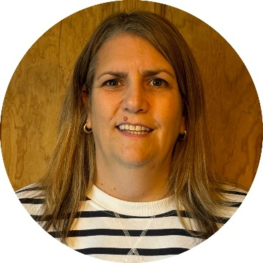
Emma Hughes
Nominee: Chair

Emma joined BBS UK as a trustee and Chair in late 2024. She has enjoyed her time working alongside the trustees, staff team and volunteers at BBS UK and is excited to continue their inspiring work supporting people with BBS, their families and carers.

Emma lives in a small village outside Petersfield in Hampshire, with her husband Phillip, two sons Charlie and Archie, dog Max and cat Zebe. She enjoys spending time with family and friends particularly going to live music and comedy gigs, finding new places to eat and movie nights at home with her children.

Emma has worked at Thomas Pocklington Trust, a national sight loss charity, since 2008 and has been at the forefront of the development and delivery of their services. In her role as Director of Services, Emma is passionate about ensuring that blind and partially sighted people are at the centre of all their activities. The Sight Loss Councils, Student Support Service, Works for Me employment service and Get Set Progress internship programme have all involved blind and partially sighted people in their formation. Emma believes that the voices of lived experience are essential in providing responsive, effective services and support.

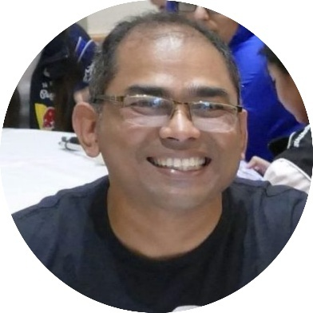
Chetan Meshram, Vice-Chair
Nominee: Trustee, Vice-Chair

Chetan joined as a trustee in 2022 and has been a member of BBS UK for over a decade. He lives in Buckinghamshire with his wife and three daughters, one of whom, Yukta, was diagnosed with BBS at birth, a journey that inspires his ongoing commitment to the charity.

Professionally, Chetan is a Lead Business Analyst in the Technology area of a major UK bank, with extensive experience in Strategy, Transformation and Financial Services. He has also volunteered for over 16 years with St John Ambulance, including leading national vaccination programme teams. Chetan strongly aligns with BBS UK’s mission to empower individuals and families living with BBS through understanding, inclusion, and support, and with its vision to improve diagnosis, transitions, and overall quality of life. His interest lies in using technology and innovation to enhance patient care, education, and wellbeing for the BBS community.

Chetan is approachable and open to discussions with parents, professionals, and advocates, working collaboratively to help those affected by BBS feel supported, confident, and connected.

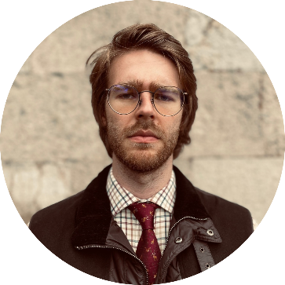
Byron Hyde
Nominee: Trustee, Treasurer

Byron Hyde joined BBS UK as a co-opted Trustee in April 2026 and is currently undertaking delegated Treasurer responsibilities. He hopes to stand for election as Treasurer at the next AGM.

Byron is a philosopher of science and public policy, working across Hokkaido University, the University of Bristol and Bangor University. His work focuses on evidence based policy, trust in institutions and standards in public life, with particular expertise in the seven principles of public life.

He serves on a range of government advisory bodies and public sector committees, with a focus on good governance and the protection of vulnerable individuals, including in areas such as research ethics, education and criminal justice.

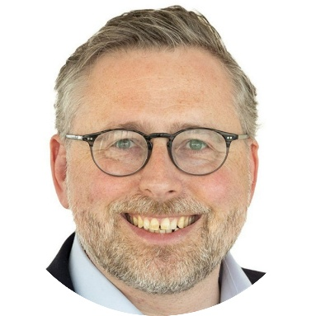
Gareth Owens, Trustee
Nominee: Trustee

Gareth joined BBS UK as a trustee in early 2023. He lives in Clapham in South London with his wife Liz and son William, who was diagnosed with BBS just before his third birthday. William loves Harry Potter, Super Mario and Horrible Histories, and has finally succumbed to supporting Nottingham Forest.

Gareth leads the Marketing & Business Development team in Europe, the Middle East and Asia for global law firm Norton Rose Fulbright, and before that worked in the B2B conference industry. His professional experience means he is well placed to help the charity with its online presence and profile-raising efforts, and he is keen to support fund raising efforts in whatever way he can.

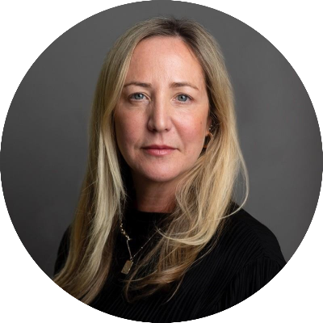
Natasha Murray
Nominee: Trustee

Natasha joined BBS UK as a co-opted trustee in November 2025 and is delighted to be part of the team. She lives in North London with her two daughters, Ella and Amber. Amber has BBS and has been her inspiration to be further involved with BBS UK thanks to the team who have supported her and her daughters. Natasha has spoken at various medical conferences alongside the BBS genetics team to raise awareness of the lived experience of hyperphagia and has given insight into medical journals on this subject.

Natasha has worked in media and marketing for over 30 years and is currently the Chief Client Officer and a member of the UK board for the media agency, Universal McCann. With her commercial and media marketing background, she is hoping to use these skills to help raise awareness, understanding and unlock funding as best she can.

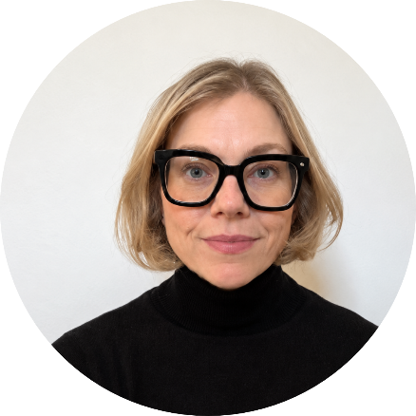
Laura Cleminson
Nominee: Trustee

Laura joined BBS UK as a co-opted Trustee in April 2026.

Laura is an experienced senior education leader with over 13 years of experience as a SENDCo, with a strong background in inclusion, safeguarding and special educational needs. She has strong links with the local SEN community and is passionate about inclusive practice and advocating for children and families.

She brings valuable governance experience from her role on a school governing body, alongside both professional expertise and personal insight as a parent of a child with Bardet Biedl Syndrome. Her son, Leo, was diagnosed at four months old and his joy and enthusiasm for life is infectious.

Laura lives on a farm in County Durham with her family and enjoys all that country life has to offer.

She is thrilled to take on the role of Trustee and looks forward to contributing to the important work of BBS UK.

