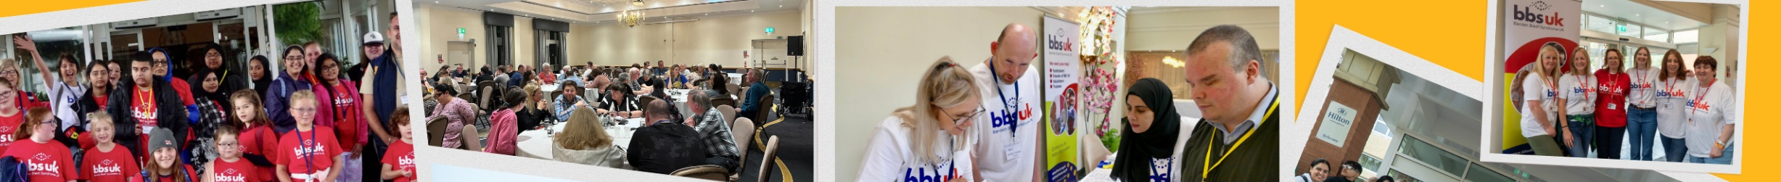

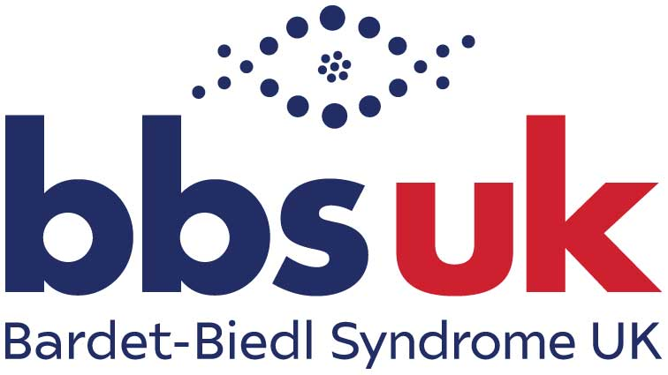

Conference 2026
26th September 2026

Livestream
Information Pack

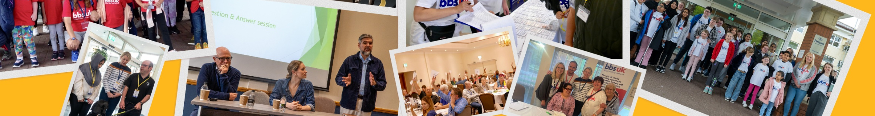
Contents
Welcome 3
Sponsors 4
Livestream Conference Programme 6
Become a member of BBS UK 7
Fundraising 7
Service User Advisory Group 9
Speaker Profiles 9
Exhibitors 14
Conference Feedback 2025 15
How did we do this year? 15
Thank you, and goodbye until next time! 15

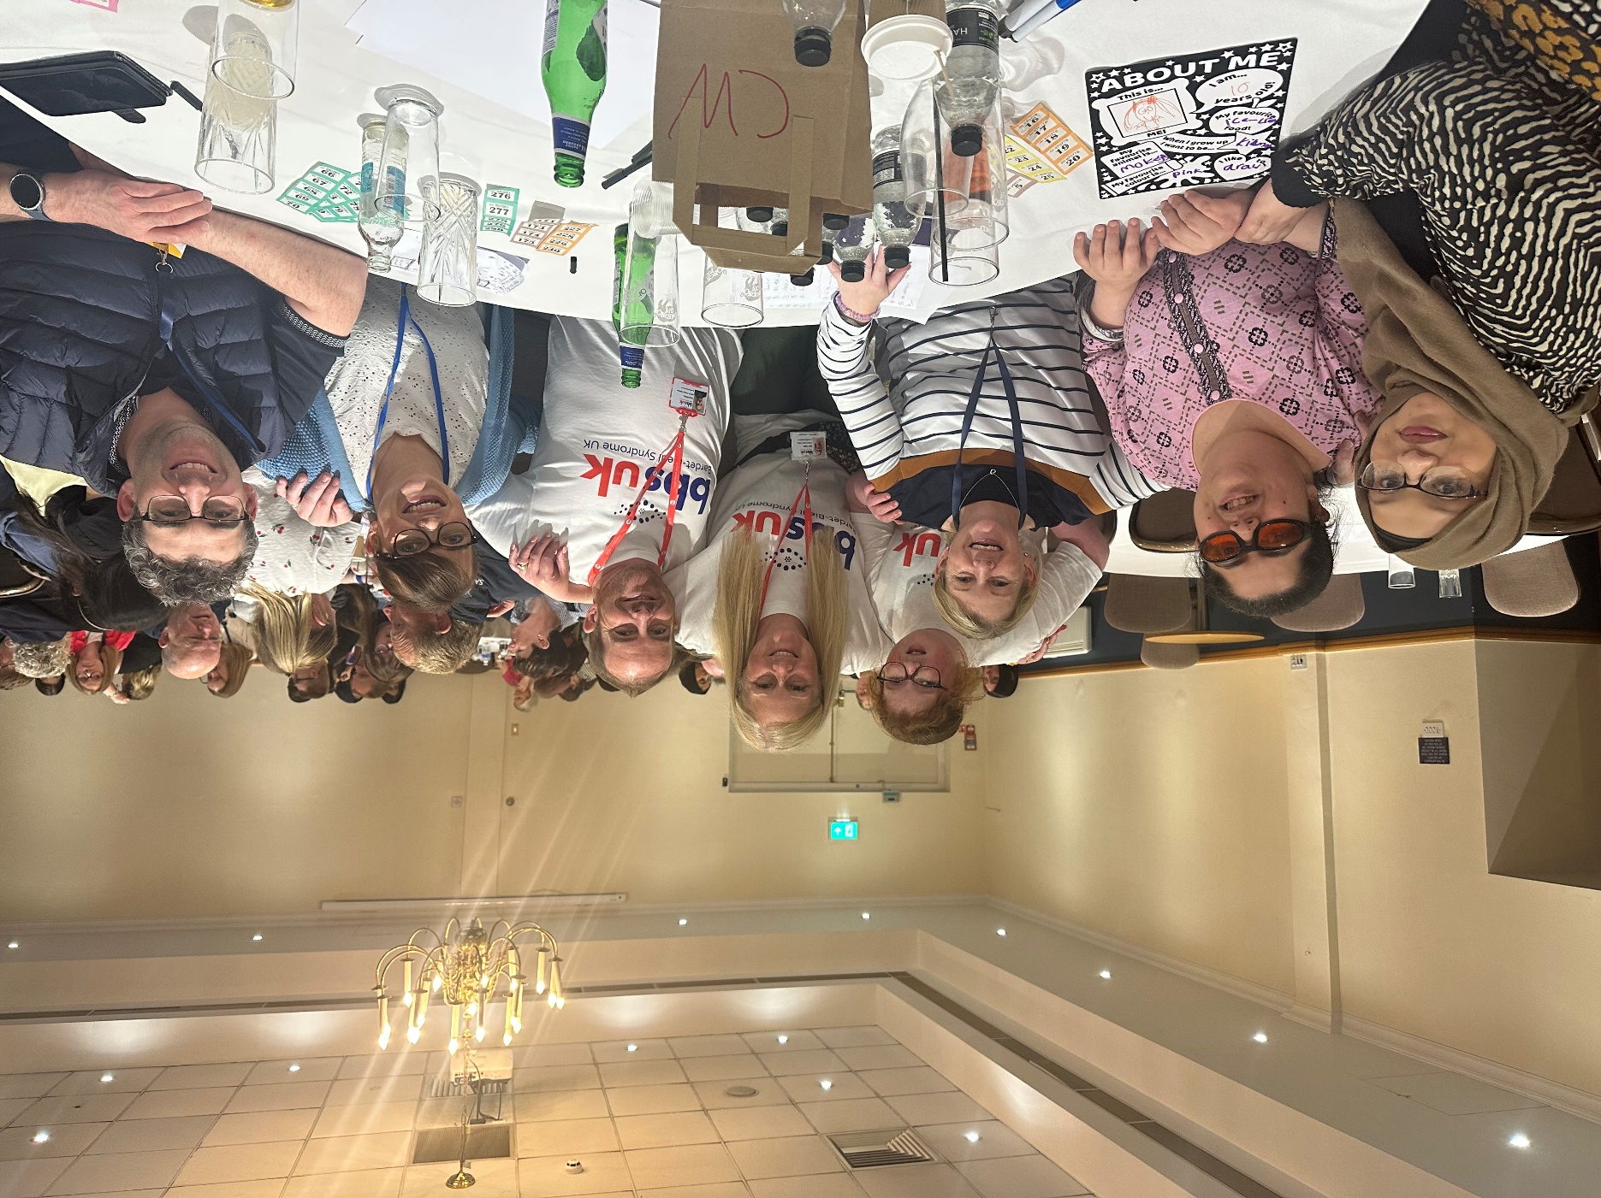

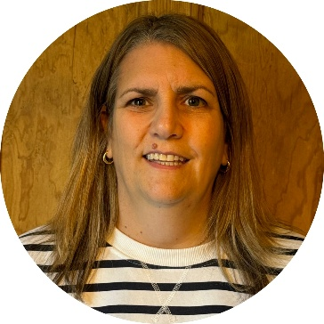
Welcome
Emma Hughes, Chair of BBS UK

A very warm welcome to everyone joining us online for the 33rd BBS UK Annual Conference. We are delighted that you are able to be part of the day with us, wherever you are joining from, and I hope you find the conference informative, uplifting and enjoyable.

BBS UK is dedicated to supporting people living with BBS and their families. Our mission is to provide guidance and support, foster research, and improve the wellbeing and quality of life of people affected by this rare condition. Our Annual Conference brings together people living with BBS, families and carers, clinicians, researchers and partner organisations to learn from one another and share knowledge and experience.

The theme for this year is Living Well with BBS. Throughout the morning, we will be looking at the progress being made in research, understanding and treatment of BBS, alongside the practical support, strategies and opportunities that can make a difference to everyday life.

During the conference, we aim to:
- showcase progress in BBS research, diagnosis and treatment
- highlight practical strategies that can improve health, wellbeing and independence
- share expertise from clinicians, researchers and people with lived experience
- strengthen connections across the BBS community
- inspire confidence, hope and action for the future.

Although you may not be with us in person, you are very much part of our Conference and our BBS UK community. We hope that joining online gives you the opportunity to hear from our speakers, learn something new and feel connected with others across the BBS community.

Please take a moment to look through the livestream programme and speaker information included in this pack. We will also send you a short feedback form after the Conference. Your feedback is extremely valuable and helps us understand what has been useful to our community and how we can continue to improve future events.

If you would like to support BBS UK, you will also find information in this pack about making a donation or becoming a Friend of BBS UK through a regular monthly contribution. As a charity, this support helps us continue providing our services, information and events for people with BBS and their families.

A special thank you to all our speakers for sharing their time, expertise and experience with us, and to our sponsors, whose generous support helps make our Annual Conference possible.

Most importantly, thank you for joining us. Whether you are watching from home on your own, with family or alongside others, we hope you feel part of everything that is happening today.

Enjoy the Conference!

Emma Hughes
Chair, BBS UK

Sponsors

Rhythm Pharmaceuticals and Axovia Therapeutics have generously supported the BBS UK conference through unrestricted educational grants. They have had no influence over the creation, development or content of the meeting.
Our heartfelt thanks go to Rhythm Pharmaceuticals and Axovia Therapeutics for their support.




Information

General
The BBS UK Annual Conference 2026 will be livestreamed via Zoom Webinar. You will have received your personal link to join the webinar by email. If you haven’t received your link, please contact admin@bbsuk.org.uk.

During the webinar, your camera and microphone will not be activated, so you will not be seen or heard by other attendees. Further information about the Conference is available on the BBS UK website.

Technical Information
To join the webinar, simply click the Zoom webinar link sent to you by email. You can join using a phone, tablet or computer. You can join through your web browser without creating a Zoom account, or use the Zoom app if you already have it.

If you are new to Zoom, we recommend watching Zoom’s ‘Joining a Zoom meeting’ video on YouTube or reading Zoom’s ‘Joining and participating in Zoom Webinars’ guide.

Before the webinar, please check that you have a good internet connection and that the sound on your device is working. If you have any technical queries with regards to accessing the conference, please contact Natalie Elsawy before the day of the event on:
admin@bbsuk.org.uk or 07784 922654.

Questions
Questions can be submitted in advance admin@bbsuk.org.uk. We will also take questions during the event via Zoom chat and the Q&A facility. If there are any questions we are unable to answer on the day, we will endeavour to provide a response to you as soon as we can after the conference.

Social Media
We welcome you to post about the conference on social media. Please use the hashtag #BBSConf26 and remember to tag us on any of the platforms listed below:
- Facebook: www.facebook.com/bardetbiedlsyndromeuk
- Instagram: bardetbiedlsyndromeuk
- LinkedIn: www.linkedin.com/company/bardet-biedl-syndrome-uk
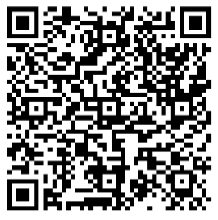
Feedback
Your feedback is important to us and will help shape future conferences
and events. After the event, please complete our conference evaluation form, available via the QR code:

Email: admin@bbsuk.org.uk,
Tel: 07784 922654
www.bbsuk.org.uk

Livestream Conference Programme
9:00am | Livestream Opens  Please join by 9:20am ready for a 9:30am start
9:30am | Welcome  Emma Hughes
9:40am | Scientific Progress and the Future of Living Well with BBS  Professor Phil Beales
10:20am | Targeting Metabolic Health in BBS: from mechanisms to practical interventions  Prof Jeremy Tomlinson  Dr Melanie Kershaw
11:00am | Break (20 mins)
11:20am | Optimising Vision & Adaptive Strategies  Dr Helen Palmer & Dr Rupal Morjaria
12:00pm | Small Steps, Big Difference  Lived Experience Panel
12:30pm | Safe, Confident & Connected in a Digital World  The 2 Johns
1:00pm | Livestream Closes

Become a member of BBS UK
Take a moment to ensure you are a member of BBS UK!
You are a member if you have completed an application form or given consent when asked by our team. If you have received Annual General Meeting (AGM) voting information in the past, you are already registered. If you're unsure, contact us at admin@bbsuk.org.uk, and we’ll check for you. BBS UK’s members are at the heart of everything we do. By joining, you become part of a supportive community that helps shape the charity’s direction and impact. Membership ensures transparency, credibility, and strengthens our ability to support individuals and families.
Membership is free! Join today at www.bbsuk.org.uk and click ‘Become a member’.

Fundraising
Throughout this event, we’ll be exploring the many things that can help people live well with BBS, from advances in research and healthcare to practical support, greater independence, shared experience and connection.
Often, it is the small steps that make a big difference. The same is true of supporting BBS UK. A monthly donation, signing up for a fundraising challenge, organising an event or supporting someone else’s efforts may feel like a small action, but together they enable us to continue providing the support, information and advocacy our community relies on.

Become a Friend of BBS UK!
One small way to make a lasting difference is to become a Friend of BBS UK by making a regular monthly donation.

Whatever the amount, regular donations give us a reliable income that helps us plan ahead and develop our support, advocacy and information services for people living with BBS and their families.
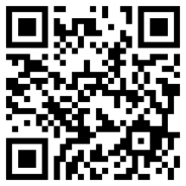
Becoming a Friend is easy:
Step 1: Scan the QR code and complete our online Friends form.
Step 2: Set up a standing order with your bank, using your name as the reference so we know who to thank.
To all our existing Friends, thank you. Your regular support makes a real difference.

Celebrating Our Amazing Fundraisers
Some small steps turn into rather big challenges!
This coming year is our biggest marathon year yet, with Team BBS UK represented at the Manchester, Edinburgh and London Marathons and the London Landmarks, Hackney and Royal Parks Half Marathons.
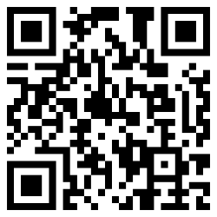
Our runners are giving their time, energy and a great many training miles to raise funds and awareness for BBS UK. We are enormously grateful to every one of them, and to everyone who sponsors, supports and cheers them on.
Scan the QR code to visit our JustGiving page and support Team BBS UK.
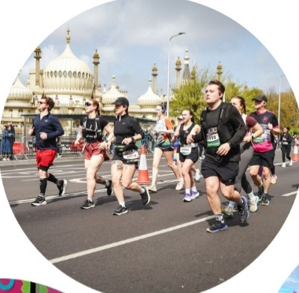
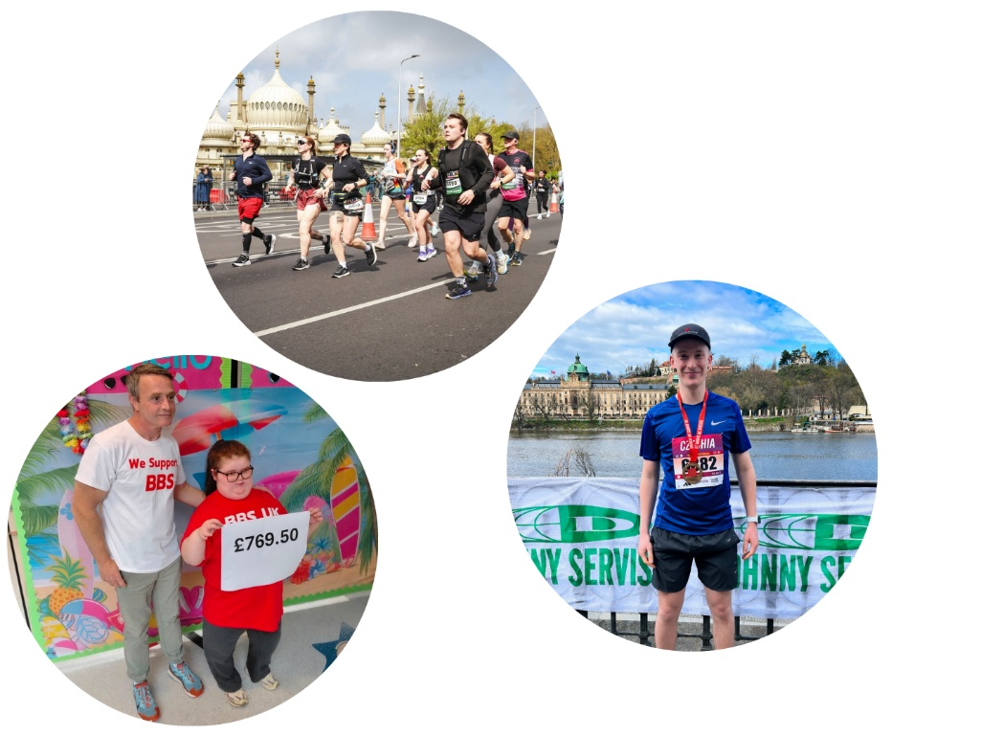

Could Your Next Step Be a Fundraising Challenge?
You don't need to run a marathon to make a difference.
You could take on a personal challenge, organise a social or workplace fundraiser, or turn something you already enjoy into a way of supporting BBS UK. Through ‘Run for Charity’, available via our website, you can also choose from events across the UK, from 5Ks and inflatable runs to marathons, Tough Mudders and bungee jumps.
Whatever you choose, we'll be here with ideas, resources and encouragement.
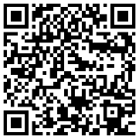
Small steps really can make a big difference. Every Friend, fundraiser and donation helps BBS UK continue our work so that people with BBS and their families have the support, information and opportunities they need to live well with BBS.
Scan the QR code, visit www.bbsuk.org.uk/support-us or email fundraising@bbsuk.org.uk to get involved.

Service User Advisory Group
The BBS UK Service User Advisory Group (SUAG) helps make sure that the experiences and views of our community are reflected in the work we do, and provides an important community voice within BBS UK. Members review our services, information and plans, and share their experiences, ideas and suggestions to help us understand what is working well and where we could do things differently or better.
SUAG feedback helps inform BBS UK’s decision-making, service development and future strategy. The group meets approximately four times a year via Zoom. Over recent years, members have contributed to a wide range of BBS UK projects, including:
- our Annual Conference
- newsletters and publications
- the Medical Information Handbook
- BBS UK’s strategy and service development.
We currently have three spaces available and would love to hear from service users who are interested in getting involved. We want the group to reflect the breadth of our community, so we are particularly keen to hear from people whose experiences or perspectives are currently less represented. At present, we would especially welcome interest from fathers of children with BBS.
If you are interested, please email Natalie Elsawy at admin@bbsuk.org.uk



Speaker Profiles
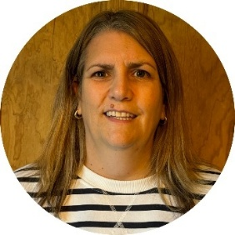
Emma Hughes

Emma lives in a village near Petersfield, Hampshire, with her husband Phillip, their two sons Charlie and Archie, dog Max and cat Zebe. Emma has worked at Thomas Pocklington Trust, a national sight loss charity, since 2008, where she is Director of Services. She has extensive experience in developing and delivering services for blind and partially sighted people and is passionate about ensuring that lived experience is at the heart of service development and decision-making.

Emma has been Chair of BBS UK for the past two years, working closely with fellow trustees, staff and volunteers to support the charity’s development and ensure that the needs and experiences of people living with BBS and their families remain central to its work. She is proud to be part of the BBS UK community and looks forward to continuing to support the charity as it develops its services, partnerships and ambitions for the future.
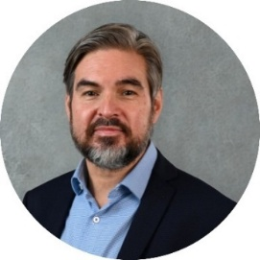
Professor Phil Beales

Professor Beales obtained his degrees in Genetics and Medicine from University College London. He undertook postgraduate training in both general medicine and paediatrics before specialising in Clinical Genetics
In 1999, he published the largest survey of BBS symptoms with the help of members of BBS UK (then LMBBS). This culminated in the identification of many new features not previously described in the medical literature and enabled Professor Beales to propose new diagnostic criteria, with the expressed purpose of enabling an earlier diagnosis for many more children.
With colleagues at Baylor College of Medicine in Houston, Professor Beales discovered the first gene to cause BBS in 2000. Since then, at least 26 genes have been linked to the syndrome, and his research group has made major advances in our understanding of its underlying causes.
Professor Beales has been medical advisor to Bardet-Biedl Syndrome UK since 1996, was made President of the Charity in 2005 and is a founder member of the BBS UK Scientific Advisory Board. In 2010, he established, with the support of BBS UK, National Multi-disciplinary Clinics, a comprehensive genetic testing platform for all persons with BBS in the UK. In recent years, he cofounded Axovia Therapeutics to deliver the first gene therapy trial for BBS.
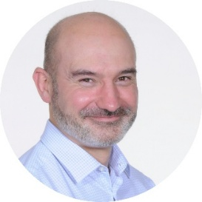
Professor Jeremy Tomlinson

Jeremy Tomlinson is a Professor of Metabolic Endocrinology and a Consultant Endocrinologist at the University of Oxford's Centre for Diabetes, Endocrinology and Metabolism (OCDEM). After studying at the Universities of Cambridge and Oxford, he completed a PhD investigating steroid metabolism and obesity before undertaking further research fellowships in obesity and insulin resistance. His research spans a range of metabolic disorders, including the specific metabolic changes associated with BBS, while his clinical practice supports patients with a broad range of endocrine and metabolic conditions.

Jeremy has been providing metabolic and endocrine expertise to the adult BBS clinic at the Queen Elizabeth Hospital Birmingham since its establishment more than 15 years ago. In this session, Jeremy will explore the metabolic health of people living with BBS, including the underlying mechanisms, associated health risks, recent research developments and emerging treatment approaches.
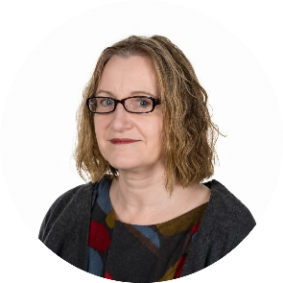
Dr Melanie Kershaw

Dr Melanie Kershaw is a recently retired Paediatric Endocrinologist with a special interest in rare Diabetes syndromes. She delivered the Birmingham clinics in the NHSE Rare Diabetes Services for Children with BBS and Alstrom Syndrome for 15 years until the end of May 2026. She was also the Clinical Lead for the BBS and the National Children's Alstrom syndrome service at Birmingham Children's Hospital for the last 5 years.

Dr Kershaw set up and delivered the Children's Setmelanotide service for children with BBS attending the Birmingham Clinics, enabling eligible children to have the opportunity to benefit from this medication. Dr Kershaw continues to support the BBS and Alstrom clinical services in BCH in an advisory role.

Her presentation will cover the pathways involved in controlling hunger and how we burn off energy in the body, and how BBS and specific medications can affect these pathways. She will also talk about the experiences and outcomes seen in children who have received specific treatment with Setmelanotide in the Birmingham clinic.
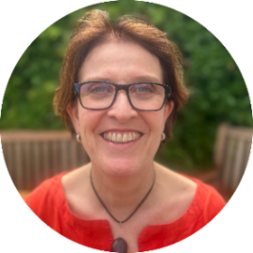
Dr Helen Palmer

Helen Palmer has been a Consultant Ophthalmologist at the Queen Elizabeth Hospital Birmingham since 2003 and she joined the Adult Bardet-Biedl Service there 10 years ago. She specialises in Medical Retinal conditions, such as those associated with diabetes. She has seen at first hand the challenges that are faced by people with BBS, as well as by their families, particularly with regards to their sight loss.

Dr Rupal Morjaria

Dr Rupal Morjaria is a Consultant Ophthalmologist specialising in macular degeneration, diabetic eye disease, central serous retinopathy, retinal vein occlusions and inherited retinal disease such as retinitis pigmentosa. She is the retinal genetics lead within her department and works as part of the specialist BBS clinic at Queen Elizabeth Hospital Birmingham.
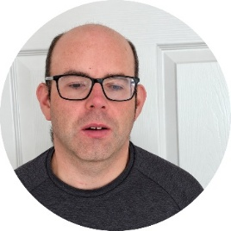
Graeme Roache

Graeme Roache is 39 years old and lives in Dumbarton Scotland. He has a black guide dog called Gibson who has been with him for over 2 years. He was diagnosed with BBS at age 9 and has limited central vision, no peripheral vision and night blindness.
He has been attending the annual conference for a number of years and supports BBS UK by organising various fundraising events. He is also a member of the Service User Advisory Group, helping to provide feedback on the charity’s projects and services.
Graeme’s interests include tandem cycling, VI tennis, going to the gym, watching sports, listening to music, audiobooks and podcasts.

Emmy Anstee

Emmy Anstee is 24 years old and was diagnosed with BBS at the age of nine. She regularly shares her experiences of living with BBS, including through appearances on podcasts such as RNIB Connect, where she talks about the adaptations and support that have helped make everyday life easier.

Emmy is also a keen volunteer and currently volunteers with a theatre company. Through her own experiences, she has learned how small changes, practical adaptations and the right support can make a real difference to confidence and independence.

By sharing her experiences on the panel, Emmy hopes to give an honest insight into life as a young adult with BBS and some of the things that have helped her along the way.

Alisha Saleem

Alisha Saleem is a second-year Social Work student from Luton, working towards a career supporting children with their mental health and wellbeing.

Alisha’s younger sister lives with BBS and growing up alongside her has given Alisha a unique perspective on how BBS can shape family life. Attending BBS UK’s annual conferences has also given her the opportunity to connect with other siblings and families who share similar experiences.

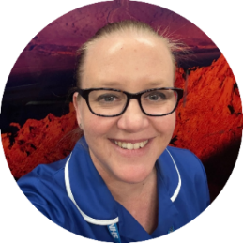
Outside of her studies, Alisha works as a carer for an elderly woman living with dementia. She is also a keen horse rider and enjoys caring for and competing with her two horses, as well as spending time with family and friends.

Samantha Newman

Samantha Newman is a nurse, and is mum to two daughters, Chloe, 16, who lives with BBS, and Makenna, 10.

As Chloe’s mum, Sam has experienced first-hand the journey of seeking a diagnosis, accessing medical support and navigating ongoing care for a child with BBS. Being both a parent and a nurse has given her a unique perspective on healthcare. She understands how important it is for parents to feel listened to, supported and included in decisions about their child’s care, while also recognising the pressures and challenges faced by healthcare professionals.

Sam hopes that by sharing her family’s experiences, she can highlight the importance of listening to families, understanding their individual circumstances and ensuring that children and their families feel heard, valued and supported throughout their healthcare journey.

Jackie O’Brien

Jackie O’Brien is 48 years old and was diagnosed with BBS in 2015, at the age of 35. She enjoys meeting and talking to people, as well as music, dancing, theatre, concerts, cooking, baking and walking.

Jackie recognises the challenges that can come with living with BBS and draws on her determination and willpower to help her overcome obstacles and continue doing the things she enjoys.

She is passionate about raising awareness of BBS and believes greater understanding and education is needed, particularly in schools and healthcare. By sharing her experiences on the panel, Jackie hopes to help others understand more about life with BBS and the difference that greater awareness and support can make.
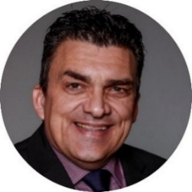
The Two Johns

John Woodley and John Staines, known as ‘The 2 Johns’, are former police detectives who spent their careers tackling online and offline child exploitation in a range of covert roles. Recognised experts in online safety, they have spent over a decade delivering engaging presentations to schools, parents, professionals and safeguarding organisations across the UK.
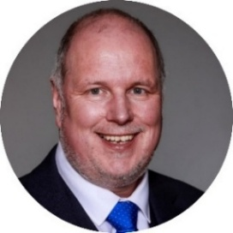
They are regular contributors to national media, including BBC Breakfast, BBC Radio 4 and Channel 4, and have helped thousands of children, families and professionals navigate the digital world safely.
Their session will cover practical ways to stay safe online, including using apps and online games safely, understanding privacy settings, and help with navigating the digital world with confidence.

Exhibitors


RNC provides further education and training for young people aged 16–25 with visual impairment. Alongside academic and vocational courses, students develop practical skills including mobility, assistive technology and independent living, helping to build confidence and independence for the future.
www.rnc.ac.uk


Guide Dogs supports children and adults with sight loss, as well as their families. Their services include support with mobility and independence, technology, education and family life. At the conference, Guide Dogs will be showcasing their Habilitation Service, Technology and Learning Service, and Family Outreach Support Service. www.guidedogs.org.uk


VICTA supports children and young adults who are blind or partially sighted, and their families. They offer inclusive activities, family weekends, sports, residential opportunities and their Young Achievers Award, helping young people build confidence, independence and friendships. www.victa.org.uk

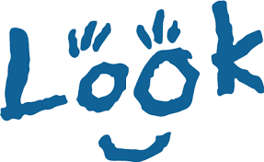
LOOK supports visually impaired children and young people, and their families, across the UK. They offer mentoring, events and activities, online communities and support for parents and carers. Their Mentor Project connects visually impaired young people with trained mentors who have lived experience of sight loss, helping them build confidence, connections and independence. www.look-uk.org


British Blind Sport aims to transform the lives of blind and partially sighted people through the power of sport and physical activity. British Blind Sport works to ensure accessible opportunities for individuals with visual impairments, from grassroots to elite levels, challenging and supporting the mainstream sport sector to be inclusive. www.britishblindsport.org.uk

Conference Feedback 2025
“Another very well organised conference, well done to the BBS UK team! This is a very important weekend for us and we hope it can continue for many years to come.”

“We really had a great time, we felt so welcomed by you all. With open arms and hearts, we were adopted by you all! ... Thank you all, you guys are awesome!”

“For my first time, I’ve left feeling very comforted and inspired. On the trains home I hit the ground running reaching out for various support and also fundraising ideas. Thank you!”

How did we do this year?

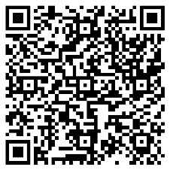
Your feedback really matters to us. Please take a few minutes to complete our conference evaluation by scanning the QR code.

Your thoughts help us understand what worked well, improve future conferences and demonstrate the impact of our work when applying for funding.

Thank you for joining us and for sharing your thoughts with us, we truly appreciate it!

Thank you, and goodbye until next time!
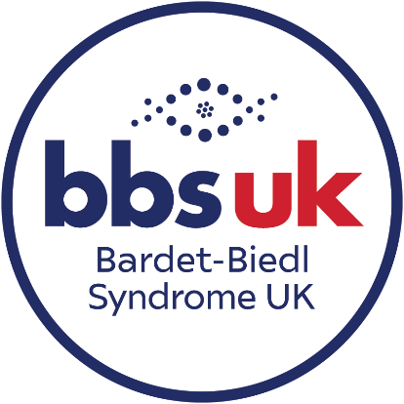
Thank you for joining us online for the BBS UK Conference! We hope you’ve enjoyed the morning, learned something new and felt connected to our wonderful BBS community. And remember, if you need information, advice or support at any time, the BBS UK team is here to help.
Bardet-Biedl Syndrome UK
43 Balton Way, Harwich, Essex, CO12 4UP
Telephone: 07784 922654
Email: admin@bbsuk.org.uk
www.bbsuk.org.uk

