Nominees for BBS UK Board of Trustees

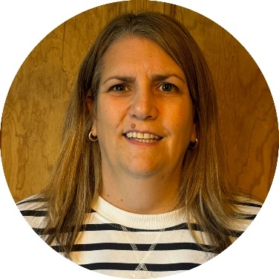
Emma Hughes
Nominee: Chair

Emma joined BBS UK as a trustee and Chair in late 2024. She has enjoyed her time working alongside the trustees, staff team and volunteers at BBS UK and is excited to continue their inspiring work supporting people with BBS, their families and carers.

Emma lives in a small village outside Petersfield in Hampshire, with her husband Phillip, two sons Charlie and Archie, dog Max and cat Zebe. She enjoys spending time with family and friends particularly going to live music and comedy gigs, finding new places to eat and movie nights at home with her children.

Emma has worked at Thomas Pocklington Trust, a national sight loss charity, since 2008 and has been at the forefront of the development and delivery of their services. In her role as Director of Services, Emma is passionate about ensuring that blind and partially sighted people are at the centre of all their activities. The Sight Loss Councils, Student Support Service, Works for Me employment service and Get Set Progress internship programme have all involved blind and partially sighted people in their formation. Emma believes that the voices of lived experience are essential in providing responsive, effective services and support.


Chetan Meshram, Vice-Chair
Nominee: Vice-Chair

Chetan joined as a trustee in 2022 and has been a member of BBS UK for over a decade. He lives in Buckinghamshire with his wife and three daughters, one of whom, Yukta, was diagnosed with BBS at birth, a journey that inspires his ongoing commitment to the charity.

Professionally, Chetan is a Lead Business Analyst in the Technology area of a major UK bank, with extensive experience in Strategy, Transformation and Financial Services. He has also volunteered for over 16 years with St John Ambulance, including leading national vaccination programme teams. Chetan strongly aligns with BBS UK’s mission to empower individuals and families living with BBS through understanding, inclusion, and support, and with its vision to improve diagnosis, transitions, and overall quality of life. His interest lies in using technology and innovation to enhance patient care, education, and wellbeing for the BBS community.

Chetan is approachable and open to discussions with parents, professionals, and advocates, working collaboratively to help those affected by BBS feel supported, confident, and connected.

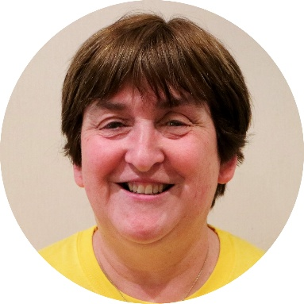

Dianne Hand, Secretary
Nominee: Secretary

Dianne has been a trustee since April 2015 and BBS UK Secretary since 2020, she says, “George, the youngest of my two sons, was diagnosed with BBS at the age of 14 in 2010. After receiving tremendous support from people connected with the Charity and learning so much at the first conference she attended, Dianne wanted to show her gratitude by supporting others and felt that being a trustee enabled her to do that.

Dianne is now retired, but for many years was a teacher and Special Needs Co-ordinator in a primary school in Stockport. She has been able to pass on useful advice and information from Stockport’s Sensory Support Service.

Dianne is currently the Secretary for BBS UK, a member of the HR and Fundraising sub-committees and gives support to the Service User Advisory Group.

“I am proud to be part of such a hard-working team that is committed to making a difference to the lives of people affected by BBS.”

On a personal note, Dianne is also a member of the Stockport Branch of the RNLI. She loves ice hockey (and wishes she were young enough to learn how to play!) and adores Manchester City FC.”


Gareth Owens, Trustee
Nominee: Trustee

Gareth joined BBS UK as a trustee in early 2023. He lives in Clapham in South London with his wife Liz and son William, who was diagnosed with BBS just before his third birthday. William loves Harry Potter, Super Mario and Horrible Histories, and has finally succumbed to supporting Nottingham Forest.

Gareth leads the Marketing & Business Development team in Europe, the Middle East and Asia for global law firm Norton Rose Fulbright, and before that worked in the B2B conference industry. His professional experience means he is well placed to help the charity with its online presence and profile-raising efforts, and he is keen to support fund raising efforts in whatever way he can.

