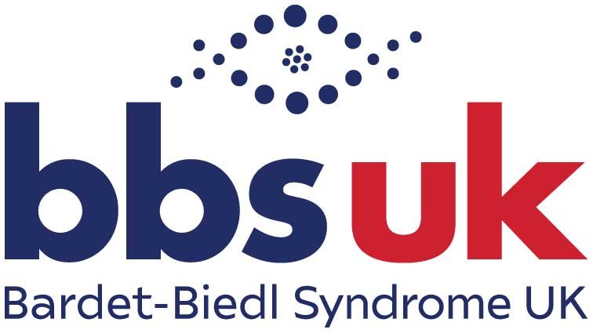

# **Conference 2025**

**25th – 27th April**

Hilton Northampton

**Information Pack**

# **Contents**

2 Welcome

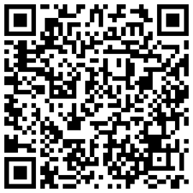

**Please remember to complete the feedback form, thank you!**

4 Useful information

5 Weekend Programme of Events

5 Friday

6 Saturday Formal Conference Programme

8 Saturday Evening

8 Sunday

8 Fundraising

10 BBS UK Membership

10 Publications

11 Service User Advisory Group

12 Speakers, Exhibitors and Sponsors

22 Thankyou and feedback form

# Welcome

Emma Hughes, Chair of BBS UK

As the newly appointed Chair of Bardet-Biedl Syndrome UK, I am honoured to welcome you to our 32nd Annual Conference. I look forward to connecting with our incredible community and sharing a weekend of learning, support, and inspiration.

Whether you're attending in person at the Hilton Northampton, or joining us via Zoom, I hope you find the event both informative and uplifting.

Bardet-Biedl Syndrome UK is dedicated to supporting individuals and families affected by BBS; our mission is to provide guidance, foster research, and enhance the wellbeing and quality of life for those living with this rare condition. This annual conference is a cornerstone of our efforts, bringing together experts, families, and individuals to share knowledge and experiences.

This year’s conference promises a rich and varied programme. Over the course of the weekend, you will:

* Hear from leading specialists on the latest research and clinical advancements.
* Gain insights from personal experiences shared by members of the BBS community.
* Learn practical strategies from professionals to help manage life with BBS.
* Have the opportunity to connect with others, ask questions, and be part of a supportive network.

To ensure you don’t miss any of the sessions and activities, please take a moment to review the Weekend Programme included in this pack. Inside, you’ll find:

* A full schedule with presentation timings.
* Speaker profiles.
* Useful information about the Charity, event and venue.

The hotel lobby will be the hub for the weekend, with easy access to the Business Corridor (where meeting rooms are located), the restaurant, bar, and bedrooms.

If you have any questions throughout the weekend, our team members in BBS UK T-shirts are here to help. Each year, we welcome new delegates alongside returning attendees, so please don’t be shy—introduce yourself, ask questions, and make the most of being part of the BBS support network.

Your feedback is invaluable to us. A link to a short feedback form is included on the back page of this booklet and will be sent via email after the conference. We encourage you to share your thoughts to help us improve future events.

If you would like to support BBS UK, information on making a one-time donation or becoming a Friend of BBS UK with a regular contribution is also included in this pack. As a charity, we rely on donations to continue providing essential support services—including this conference—which are more vital than ever.

A special thank you to our incredible speakers, whose expertise and dedication help make this event possible. Their contributions are essential in advancing our collective understanding of BBS and ensuring continued support for those affected.

We look forward to a weekend of learning, sharing, and, most importantly, connecting.

Enjoy the conference!

Emma

# Useful Information

**Wi-fi**

The hotel offers free unlimited Wi-Fi for all guests. The code is: meetings2023

**Social media**

We welcome you to post about the conference on social media! Please use the hashtag #BBSConf25 and remember to tag us on any of the platforms listed below:

* **Facebook:** www.facebook.com/bardetbiedlsyndromeuk
* **Instagram:** bardetbiedlsyndromeuk
* **X:** @BBS__UK
* **LinkedIn:** www.linkedin.com/company/bardet-biedl-syndrome-uk

**Urgent enquiries only, during the weekend**

**At the hotel**

Rebecca Perfect: 07421 455649

Natalie Braunton: 07785 922654

**Children and Young Person's Trip**

Angela Scudder: 07591 206788

Laura Davis: 07512 198484

Amy Clapp: 07591 206787

**\*All emergencies must go through Hotel Reception\***

**Coronavirus and other serious illnesses**

Some people attending the Conference will be highly vulnerable. We ask that if you have symptoms of Coronavirus, then please take a test. If your result is positive, please do not attend the event. If you have any other serious contagious illness, please access the event online instead.

**Photography and video during the weekend**

Please be aware that photos and video will be taken during the weekend for use in our publications, on our website and on social media. If you do not wish to appear in any photos or videos, please request an opt-out form from a BBS UK team member.

# Weekend programme of events

*\*Please note that timings are subject to change*

# **Friday**

|  |  |  |
| --- | --- | --- |
| **Time** | **Activity** | **Location** |
| From 3pm | Registration and check-in to hotel. | Hotel lobby |
| 6pm to 7:30pm | Evening meal (rolling service) | Seasons Restaurant |
| 7pm to 8pm | Children & Young People's Group:  Yoga and Mindfulness  Meet the Scientists | Collingtree 1  Spencer Room |
| 7:30pm to 8pm | New Attendee Meeting: Adults living with BBS | Isham Room |
| 8pm to 9.30pm | Social meet-up for adults living with BBS | Collingtree 2 |
| 8pm to 9pm | New Families Meeting: Parents | Isham Room |

**Prayer Room:** A quiet room is available during conference weekend for individual prayer and reflection.

**Advice Service Appointments Available**

Our Advice Service Manager, Rebecca Perfect will be available for pre-arranged appointments across the weekend. Please contact Rebecca directly by emailing **rebecca.perfect@bbsuk.org.uk** to reserve a space.

**Invitation for adults living with BBS**

Would you like to meet and chat to other people who are also living with BBS? Come and join us on Friday 25th April from 8pm to 9:30pm in Collingtree 2. We will be chatting, sharing experiences and playing some fun games.

Hosted by BBS UK volunteer Maria Dowswell.

# **Saturday**

|  |  |
| --- | --- |
| 8:30am | Registration and refreshments for day delegates in hotel lobby |
| 8:45am | **Drayton Manor trip for children and young people:**  Assemble outside for group photo and prompt 9am departure |
| 9:00am | **Conference opens in Collingtree Suite**  at end of Business Corridor |
| 9:15am | **Welcome**  Emma Hughes, Chair, BBS UK |
| 9:20am | **Update on Gene Therapy**  Professor Phil Beales, Axovia Therapeutics |
| 10:00am | **Therapeutic Approaches for Retinal Dystrophies**  Robert Henderson, Consultant Ophthalmologist & Vitreoretinal Surgeon, GOSH & Moorfields Eye Hospital |
| 10:40am | **Setmelanotide Clinics Update**  Dr Elizabeth Forsythe |
| 11:05am | **Break** (20 mins) |
| 11:25am | **Planning for the Future – Wills, Trusts and Decision Making**  Philip Warford, Renaissance Legal |
| 11:50am | **Personal Perspective**  An interview with Stefan Crocker |
| 12:10pm | **Staying Safe Online**  Sophie Corness, Royal National College for the Blind (RNC) |
| 12:35pm | **Update from BBS UK**  Tonia Hymers, Operations Manager, BBS UK |
| 1:00pm | **Lunch**  in Seasons Restaurant and Lobby |

After lunch we will split into two groups for more focused sessions:

**Collingtree 1:** People Living with BBS

**Collingtree 2:** Parents of Children & Young People Living with BBS

|  |  |
| --- | --- |
| 2:00pm | Thinking About Food  Kenneth Michie, Dietitian, GSTT  Dr Emma McGibbon, Clinical Psychologist, GSTT |
| 2:50pm | **The Power of Peer Support**  Denise Rawden, Retina UK |
| 3:15pm | **Comfort break** (15 mins) |
| 3:30pm | **Communication at a cellular level: An accessible update**  Dr Emilia Kieckhöfer, Julia Günzler, Cologne, Germany  Jannis von Spreckelsen, Viola Kretschmer, Mainz, Germany |
| 4:00pm | **Personal Perspective**  Emily Bartell, USA |
| 4:20pm | **Closing Remarks:** Emma Hughes, Chair, BBS UK |
| 4:25pm | **Refreshments and Networking:** Lobby |

People Living with BBS: **Collingtree 1**

Parents of Children/Young People: **Collingtree 2**

|  |  |
| --- | --- |
| 2:00pm | Supporting Transition to Adulthood  Marie McGee, Transition Co-ordinator, Birmingham Children’s Hospital and Anna Smith, Rareminds |
| 2:50pm | **Cognitive, Behavioural and Social Presentations in Children and Young People with BBS**  Dr Gabrielle Blumer and Dr Emma McGibbon |
| 3:20pm | **Comfort break** (10 mins) |
| 3:30pm | **Habilitation: What to Expect in Your Child's Mobility & Independence Programme**  Suzy McDonald, Habilitation VI UK |
| 3:55pm | **Dietary Support**  Sarah Flack, Principal Dietitian, Great Ormond Street Hospital |
| 4:25pm | **Closing Remarks:** Chetan Meshram, Vice-Chair, BBS UK |
| 4:30pm | **Refreshments and Networking:** Lobby |

# **Saturday evening**

|  |  |  |
| --- | --- | --- |
| **Time** | **Activity** | **Location** |
| 6:30pm-8pm | Evening meal (rolling service) | Seasons Restaurant |
| 7:30pm | Pop-Up ‘Cinema’ showing Disney Movies (Unsupervised) | Lowther Room |
| 8:30pm-10:30pm | Family Quiz and Raffle | Collingtree Suite |

# **Sunday morning**

|  |  |  |
| --- | --- | --- |
| **Time** | **Activity** | **Location** |
| Goalball with Kathryn Fielding of **GoalBall UK** | | |
| 9am – 10am | Children and Young People | Collingtree Suite |
| 10am – 11am | Adults Living with BBS | Collingtree Suite |

# Fundraising

**Sign up as a Friend and get a free gift**

By making a regular monthly donation, no matter how big or small, you will be helping BBS UK to plan ahead and make long-term developments to our much needed, and highly regarded support, advocacy and information services. A regular gift allows us to plan strategically as we know day in, day out that we will have a steady income that we can rely on. It’s really easy to do, just follow the steps below:

**Step 1:** Fill in the online Friends form by scanning the QR code

**Step 2:** Setup a standing order with your bank, using your name as a reference so we know who to thank

All new sign-ups during conference weekend will receive a free gift! If you are attending in person, go to the BBS UK reception table to collect yours!

**Our heartfelt thanks go to all of our ‘Friends’ for their generous donations!**

**London Marathon**

Conference Sunday is the London Marathon, and it’s extra special for our community as one of our own, Michael O’Sullivan, is taking on the challenge for a deeply personal reason—his sister, Mary who has BBS. For Michael, BBS UK has been a vital source of support for their family, providing guidance, reassurance, and a sense of belonging. He said, "BBS UK has been a constant support to our family through the years. Raising funds for this charity is my way of giving back to the organisation that has done so much for us and countless others."

Michael set an ambitious goal to raise £8,000 for BBS UK, and we would love to show our support this weekend with a boost to his JustGiving page – every amount, big or small, will directly support the work of BBS UK.

Donate now via JustGiving by scanning the QR code:

**Royal Canal Extreme run**

Next weekend, three dedicated runners from Ireland, David McLynn (Ballymahon), Wesley Jordan (Lanesboro), and Fintan Cruse (Roosky)—will take on an extraordinary challenge: running the full length of Dublin’s Royal Canal non-stop.

Covering 149.7 km (89 miles) from Dublin to Clondra, Co. Longford, they will run through the night and into the next day, pushing their limits to raise funds and awareness for three incredible charities, including BBS UK.

All funds raised will be split evenly between these charities,

helping them continue their vital work.

We’re calling on our community to rally behind these incredible athletes and donate via iDonate, accessed through the QR code

on the right, to help them reach their fundraising goal.

Their journey is a true test of endurance and determination, and we are so grateful for their commitment to making a difference. Let’s show our support and help them go the distance!

# Become a member of BBS UK

Take a moment to ensure you are a member of BBS UK!

You are a member if you have completed an application form or given consent when asked by our team. If you have received AGM voting information in the past, you are already registered. If you're unsure, contact us at **admin@bbsuk.org.uk**, and we’ll check for you.

BBS UK’s members are at the heart of everything we do. By joining, you become part of a supportive community that helps shape the charity’s direction and impact. Membership ensures transparency, credibility, and strengthens our ability to support individuals and families.

**Membership is free!** Join today at www.bbsuk.org.uk and click ‘Become a member’.

# Publications

Available from BBS UK in multiple formats:

* Introducing Bardet-Biedl Syndrome (also available in EasyRead, Urdu and Turkish)
* Medical Information Booklet (new edition available now!)
* Booklet for Schools and Colleges
* My Life, My Future – Young Person’s Handbook

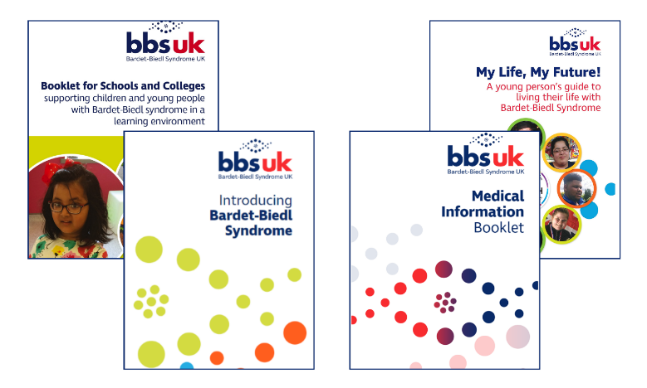

Copies can be downloaded via **www.bbsuk.org.uk** or accessed via the QR code above, right. Or you can email **admin@bbsuk.org.uk** for a copy by post.

# A group of green dots AI-generated content may be incorrect.Service User Advisory Group

The BBS UK Service User Advisory Group (SUAG) is a sub-group of BBS UK. Membership of the group is representative of our community, including people with BBS, parents and carers of those with BBS, from England, Scotland, Wales, and Ireland, whilst also ensuring cultural representation.

The group is chaired by BBS UK trustee, Rachael Zimbler, with support from trustee, Dianne Hand, and BBS UK Operations Assistant, Natalie Braunton.

**What does SUAG do?**

SUAG reviews BBS UK’s services and provides feedback and suggestions on how to improve them and make them even better.  We are sometimes asked by external organisations, for example, researchers, sight loss charities, or pharmaceutical companies, to review documents or processes, which SUAG will also support. The work of SUAG will inform BBS UK decision making and support improvements and strategy development.

Since January 2023, the SUAG members have met five times on Zoom and provided feedback and suggestions to BBS UK about our services and projects including:

* Conference
* Newsletter
* Medical Information Handbook
* Community Audit
* BBS UK’s three-year strategy

We are immensely grateful for the SUAG members for volunteering their time over the past year and for sharing their suggestions for how to ensure our services are right for our community.

**Would you like to join?**

We currently have four spaces in the group and to ensure a diverse range of service users and views, we are currently looking for male applicants, including those living with BBS, and fathers of children with BBS.

If you are interested, please email Natalie Braunton at **admin@bbsuk.org.uk.**

# A group of green dots AI-generated content may be incorrect.Speakers

**Emma Hughes,** Chair of BBS UK

Emma lives in a village near Petersfield, Hampshire, with her husband Phillip, two sons Charlie and Archie, dog Max, and cat Zebe. She enjoys spending quality time with family and friends, particularly attending live music and comedy events, exploring new places to eat, and having movie nights with her children at home.

Emma has worked at Thomas Pocklington Trust, a national sight loss charity, since 2008, playing a key role in developing and delivering services for blind and partially sighted people. As Director of Services, she is passionate about ensuring that individuals with sight loss are at the heart of all initiatives. Emma believes that services must be shaped by lived experience to be truly effective. She is excited to join Bardet-Biedl Syndrome UK, continuing their inspiring work.

**Professor Phil Beales,** Great Ormond Street Institute of Child Health Guys and St. Thomas’ NHS Trust and Co-founder & CEO at Axovia Therapeutics.

Professor Philip Beales obtained his degrees in Genetics and Medicine from University College London. He undertook postgraduate training in both general medicine and paediatrics before specialising in Clinical Genetics.

In 1999, Professor Beales, with the help of BBS UK, published the largest survey of BBS symptoms, identifying many new features and proposing new diagnostic criteria to enable earlier diagnosis. He and colleagues at Baylor College of Medicine discovered the first BBS-related gene, BBS6, and since then, 25 genes have been linked to the syndrome. In 2010, Professor Beales founded the national multi-disciplinary clinics.

Now based at The Institute of Child Health, Professor Beales leads the Cilia Disorders Laboratory. His research, in collaboration with European and North American teams, has advanced our understanding of BBS, particularly the role of dysfunctional cilia. These findings are moving closer to treatments that may prevent visual deterioration or weight gain.

Professor Beales has been medical advisor to BBS UK since 1996 and is a founder member of the BBS UK Scientific Advisory Board.

**Robert Henderson,** Consultant Paediatric Ophthalmologist & Vitreoretinal Surgeon, Great Ormond Street Hospital & Moorfields Eye Hospital; Honorary Associate Professor, UCL-GOSH Institute of Child Health.

Robert Henderson specialises in the surgical and genetic management of paediatric retinal diseases. He leads the inherited retinal dystrophy clinic at Great Ormond Street Hospital and established a dual sensory clinic for families affected by combined vision and hearing loss. He also directs the Voretigene ocular gene therapy program and is the North Thames Specialty Lead for Ophthalmic Genomics.

Robert’s research focuses on Wnt signalling in retinovascular diseases, and he is dedicated to developing groundbreaking treatments for rare inherited retinal diseases, including CLN2, CLN5, USH1B, and RPGR-related Retinitis Pigmentosa. Additionally, he is advancing subretinal photoreceptor stem cell therapy.

**Dr Elizabeth Forsythe,** MRC Clinical Research Fellow (Clinical Genetics), University College London, Great Ormond Street Institute of Child Health

Dr Elizabeth Forsythe has degrees in molecular medical sciences and medicine from Queen Mary University of London. She trained in adult medicine and paediatrics before specialising in clinical genetics at Northwick Park Hospital and Great Ormond Street Hospital, where she is currently a registrar. Dr Forsythe has over ten years research and clinical experience in Bardet-Biedl syndrome and has been involved in the BBS Clinics in London since their inception in 2010. Her PhD in Bardet-Biedl syndrome was supported by the Medical Research Council and the Great Ormond Street Hospital Children’s charity. In addition to her clinical work, Dr Forsythe is a passionate advocate for patient engagement and sits on the board of the Ciliopathy Alliance and BBS UK Scientific Advisory Board.

**Philip Warford,** Managing Director, Renaissance Legal

Philip is the Managing Director of award-winning law firm Renaissance Legal, which specialises in advising parents and carers of disabled and vulnerable individuals with planning for the future.

Philip is passionate about providing these groups access to the very best specialist legal advice and he and the team regularly deliver legal clinics and webinars for and on behalf of many local and national charities.  He is recognised as a leading expert in the field of private client law by the Legal 500 and Chambers and Partners.

**Stefan Crocker**

Stefan was diagnosed with BBS in 2003. He achieved a BA (Hons) in Politics from the University of Portsmouth in 2014 and served as a BBS UK Trustee from 2015 to 2024.

During his nine years on the board, Stefan served as Trustee, Vice-Chair, and Chair, helping to develop key events and projects. He has also represented BBS UK internationally, volunteering at conferences and information days in Germany and the United States.

Beyond his work with BBS UK, Stefan volunteers for Sight Loss Councils and enjoys playing VI tennis. A keen traveller, he frequently explores the UK and beyond, embracing a positive approach to life with sight loss.

**Sophie Corness**, Royal National College for the Blind (RNC)

Sophie Corness has been the Marketing and Student Recruitment Manager at the Royal National College for the Blind for five years and has over a decade of experience in education marketing and recruitment.

In her role, she manages social media accounts and helps safeguard young people’s digital footprints. Having witnessed the rapid evolution of online identities, she regularly advises young people on how to stay safe while engaging in the digital world.

**Tonia Hymers,** Operations Manager, BBS UK

Tonia lives on the coast in Essex with her husband, Rob and two sons, Daniel and Connor. Tonia joined the Board of Trustees in 1998 after Dan’s BBS diagnosis, taking on roles of Fundraising Coordinator and Newsletter Editor. The family’s first conference that year gave them hope for a positive future, thanks to the young people and adults they met, who were living with BBS.

Having worked at Barclays for 17 years, Tonia left in 2002 to focus on her family. Over the years, Tonia has enjoyed studying with the Open University, earning a First Class BSc in Social Sciences and a Masters (Open) with Merit. Tonia worked alongside the Charity and Professor Beales to develop the BBS UK clinics service provision, before taking on the role of Children’s Service Manager, Service Manager, and later Operations Manager.

Tonia is incredibly proud of Dan and Con and how the family have dealt with the challenges over the years. As a family they are learning to sail and love spending time on the water or walking nearby with their dogs.

**Sarah Flack,** Principal Dietitian, Great Ormond Street Hospital

Sarah Flack has worked at Great Ormond Street Hospital for over 20 years and has covered a wide variety of clinical areas during this time. Sarah previously specialised in looking after children with kidney problems and in this role first saw children with BBS.

Sarah has been an integral member of the BBS multi-disciplinary clinics team since it began in 2010 and has developed a deep understanding and clinical knowledge of dietary issues in BBS and its impact on those affected and their families. Sarah has worked closely with BBS UK over the years, providing chapters for information booklets, dietary articles for newsletters, giving presentations and running workshops at annual weekend conferences, further extending the dietary support and learning for BBS families.

**Dr Emma McGibbon**, Clinical Psychologist, Great Ormond Street Hospital, Guys and St Thomas’

Dr Emma McGibbon works within the BBS services within Great Ormond Street Hospital and Guys and St Thomas’. Working across these services means that she has an understanding and expertise in how BBS can impact people across the whole lifespan.

Emma has worked in children’s services since qualifying as a Clinical Psychologist, in community settings, as well as in specialist and national centres. Emma specialises in work with neurodevelopmental differences, including intellectual disabilities, sensory impairments, cerebral palsy, autism spectrum condition, ADHD and associated emotional wellbeing, behaviour and learning needs. She is keen to develop services for people with BBS and their families and works closely with colleagues at BBS UK to ensure that the right support is being provided.

**Kenneth Michie,** Clinical Lead Dietitian, Guy’s and St. Thomas’ NHS Foundation Trust

Kenneth has been working as a specialist dietitian at Guy’s and St. Thomas NHS Foundation Trust for over 20 years. His clinical interests are in weight management, diabetes and renal disease. He has been involved with the adult BBS clinic since its inception at Guy’s Hospital Genetics Department in 2010.

**Denise Rawden,** Head of Information & Support, Retina UK

Denise joined the charity sector over 20 years ago after a career in the banking industry. Denise is passionate about supporting the inherited retinal dystrophy community by offering emotional support and providing accurate, clear information to help people make informed choices about their future.

Denise’s role involves developing and supporting impactful services for both the community and the professionals who support them. This includes a range of peer support services as well as Unlock Genetics and Discover Wellbeing resources and the development of offerings specifically for professionals who support the Inherited Retinal Dystrophies (IRDs) community.

**Dr Emilia Kieckhöfer,** University Hospital Cologne, Internal Medicine II, CECAD, Nephrolab

Emilia became part of the ciliopathy research community during her Master's studies in the group of Prof. Helen May-Simera. Fascinated by cilia biology and, in particular, the pathogenesis of Bardet-Biedl syndrome (BBS), she pursued her PhD in the Nephrolab Cologne, investigating the role of regulated cell death as a potential therapeutic target in kidney-affecting ciliopathies. During this time, she also initiated a project on BBS8, uncovering mechanisms contributing to cystic kidney disease.

Now, as a postdoctoral researcher in the Nephrolab Cologne, she is expanding her focus on kidney-related aspects of BBS. Driven by a passion for discovery and meaningful impact, she is eager to push boundaries, generate new insights, and actively support the BBS research community through her work.

**Julia Günzler**, University Hospital Cologne, Internal Medicine II, CECAD, Nephrolab

Julia recently began her PhD in the Nephrolab Cologne, focusing on regulated cell death in ciliopathies and contributing to Emilia’s BBS8 project.

Last year, she had the opportunity to attend the BBS Patient Days in Germany, where she engaged with patients and gained valuable insights into their experiences. This interaction further fuelled her passion for BBS research.

Now, as main topic of her PhD, she is concentrating on DNA damage in chronic kidney disease and ciliopathies such as BBS, aiming to uncover new mechanisms and potential therapeutic approaches.

**Dr Viola Kretschmer,** Cilia Cell Biology, Johannes Gutenberg-University Mainz

Dr. Viola Kretschmer has been a scientist and lab manager in Prof Helen May-Simera's lab since 2015 with a primary focus on retinal degeneration, visual impairment, and therapeutic approaches for Bardet-Biedl Syndrome. Over the past decade, as our understanding of cilia and their crucial role in cellular communication has grown, her research has expanded to explore their impact on other tissues and organs. She was also an honorary member of the Cilia Cyclists 2022 and is looking forward to further cycling adventures to raise awareness and support for BBS UK.

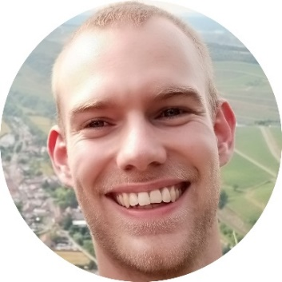**Jannis von Spreckelsen,** Johannes Gutenberg-University Mainz

Jannis von Spreckelsen started his PhD in the laboratory of Prof Helen May-Simera this year. He completed his Master’s in the same lab, where he researched the role of cilia in signalling within the kidney. This work provided exciting insights into how cilia send and receive signals and how these processes are impacted in Bardet-Biedl Syndrome. He is looking forward to connecting with the BBS UK community.

**Emily Bartell**

Born in North Carolina, USA, Emily was diagnosed with BBS in 1991. She earned a bachelor's degree in art from Warren Wilson College in 2014 and later pursued a career in massage therapy, graduating from the Western North Carolina School of Massage in 2019.

Emily received her first guide dog from The Seeing Eye in Morristown, New Jersey, in 2015. A passionate traveller, she has lived on three continents for extended periods, visited over 14 countries, and explored 22 U.S. States. Her dedication to service earned her the Bronze Congressional Award after completing more than 1,700 hours of community service.

With strong family values rooted in respect, integrity, and honesty, Emily embraces life through her many interests, including traveling, playing guitar, hiking, reading, and swimming.

**Marie McGee,** Transition Co-ordinator, Birmingham Women's and Children’s Hospital NHS Foundation Trust

Marie has over 30 years of experience in the NHS, education, commissioning, and charity sector. As the Transition Coordinator at Birmingham Children’s Hospital, Marie supports young people with Bardet-Biedl, Alström, and Wolfram syndromes to develop knowledge and skills for their move to adult Rare Disease Clinics. She collaborates across health, education, social care, and other community services to provide young people and their families with information and signposting to make informed choices.

**Anna Smith**, Integrative Psychotherapist, Rareminds

Anna Smith is an Integrative Psychotherapist and a registered member of the UK Council for Psychotherapy (UKCP).

She has worked predominantly with children and families within schools and private practice, supporting them through family issues, developmental difficulties, trauma and living with neurodiversity and other special educational needs.

She has a special interest in how the needs of a child impact the family set up and how the needs of a family unit impact a child.

**Dr Gabrielle Blumer,** Clinical Psychologist, St George’s Hospital

Dr Gabrielle Blumer is a Clinical Psychologist working across paediatric and adult neuropsychology services at St George's Hospital. She has worked with children with a range of neurological and neurodevelopmental presentations across settings, including a post in the BBS clinic at Great Ormond Street Hospital.

Gabby’s doctoral research was focused on investigating the cognitive, behavioural and emotional profiles of children and young people with BBS and considering how these factors relate to quality of life.

**Suzy McDonald,** Senior Habilitation Specialist, Birmingham Education Habilitation Service, Treasurer for Habilitation VI UK

Suzy McDonald is the Senior Habilitation Specialist for the Birmingham Education Habilitation Service. Based at Priestley Smith Specialist School, Suzy works with vision impaired children and young people in a variety of mainstream and special schools across Birmingham.

The aim of the Habilitation Service is to develop each child's mobility and independence skills to the best of their potential. She joined the service in 2009 after 17 years at RNIB, including 9 years as RNIB’s Curriculum Access Officer. Suzy is attending the conference representing Habilitation VI UK, the professional body for Habilitation Specialists where she holds the trustee role of treasurer.

**Chetan Meshram,** Vice-Chair of BBS UK

Chetan joined BBS UK as a trustee in late 2022 and has been an active member for over a decade. Living in Buckinghamshire with his wife and three daughters, one of whom, Yukta, was diagnosed with BBS at birth, Chetan’s personal experience continues to fuel his passion for supporting the BBS community.

Professionally, Chetan works as a Lead Business Analyst in the technology division of a major UK bank, with over 16 years of volunteer experience with St John Ambulance (SJA). Chetan is approachable and welcomes conversations with parents, professionals, and advocates who share similar struggles.

**Kathryn Fielding,** Development Officer, Goalball UK

Kathryn has been involved in the Paralympic sport of goalball for over 20 years. As part of the development team at Goalball UK, the sport’s National Governing Body, she supports clubs, delivers taster sessions, organises workplace team-building days, recruits and trains coaches and officials, and helps run competitions and initiatives to raise awareness.

At the conference, practical sessions will showcase how goalball is played using an audible ball and a tactile court, with fun activities for all—including sighted family members, as everyone wears eyeshades. Attendees can meet Goalball UK players, hear their experiences, and learn about local opportunities to get involved.

**Exhibitors

The Royal National College for the Blind (RNC) is the UK's leading college for further education and training for visually impaired young people aged between 16 and 25.

Being a national centre of expertise for students with visual impairment, RNC provides a broad curriculum which is underpinned by specialist skills for life including mobility, assisted technology and independent living. The college experience is more than vocational and academic qualifications. It's about achievement beyond the classroom - developing self-confidence, personal independence and communication skills that are needed for the future.  **www.rnc.ac.uk**

Guide Dogs provides life-changing support for people with sight loss through guide dogs, mobility services, campaigns and more. From birth to adulthood, we support children, young people and their families to feel good and function well in a highly visual world. We do this by ensuring they have the skills, information and support they need.

Guide Dogs will be exhibiting their Habilitation Service, Technology and Learning Service, and Family Outreach Support Service. **www.guidedogs.org.uk**

Retina UK is dedicated solely to working for people affected by inherited sight loss. They provide hope for tomorrow through stimulating and funding medical research, and the information and support they provide help people lead better lives today.

The charity offers a range of services including a Helpline; telephone Talk & Support Service, Discover Wellbeing support and a range of Local Peer Support Groups, both in person and online; including some special interest groups such as the Talking Technology and newly launched Talking Home and Garden. Services and information provided are driven by feedback from community and regular surveys provide the opportunity to have your voice heard. **www.retinauk.org.uk**

# Sponsors

Rhythm Pharmaceuticals and Axovia Therapeutics have generously supported the BBS UK conference through unrestricted educational grants. They have had no influence over the creation, development or content of the meeting.

Our heartfelt thanks go to Rhythm and Axovia for their support.

# Conference Feedback 2023

“I loved it so much and cannot wait for it to be back!”

“We really had a great time, we felt so welcomed by you all. With open arms and hearts, we were adopted by you all! ... Thank you all, you guys are awesome!”

“We found the conference informative, welcoming, organised, fun, kind, and a wonderful opportunity to connect with the BBS community and professionals. It is a special place to come, and we value, and are extremely grateful for all the hard work and commitment of the BBS team to bring us all together.”

“It is always great to hear about the scientific developments. The personal perspectives are always emotional because they remind you of where you were, but they also remind you of how far you have come.”

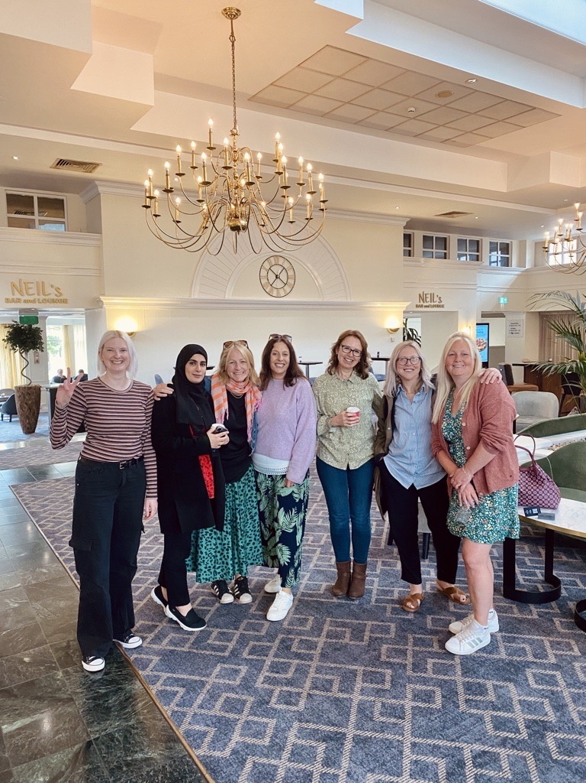

# Thank you, and goodbye for another year!

Thank you for being part of the BBS UK Conference! We hope you’ve had a fantastic time—learning, connecting, and sharing experiences with others in our wonderful community.

What did you think?

Your thoughts matter to us! Please take a few minutes to complete our evaluation form by scanning the QR code. Your feedback helps us improve and ensures future conferences continue to support and inspire. It’s quick, easy, and makes a big difference. Thank you for being here and for sharing your thoughts with us, we truly appreciate it!

**Bardet-Biedl Syndrome UK**

43 Balton Way, Harwich, Essex, CO12 4UP

Telephone: 07784 922654

Email: admin@bbsuk.org.uk

**www.bbsuk.org.uk**