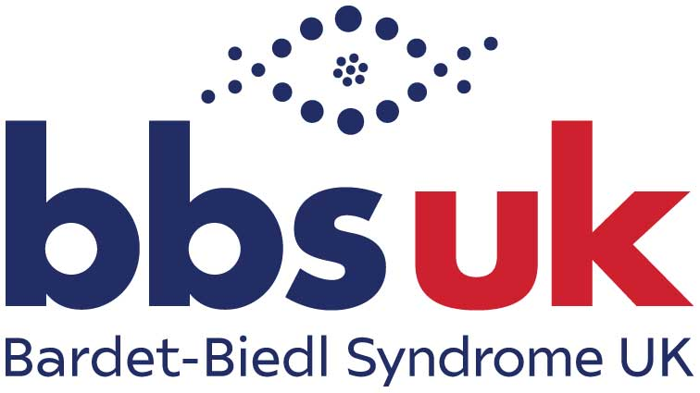

TRUSTEES’ REPORT AND ACCOUNTS

FOR THE YEAR ENDED 31st MARCH 2022

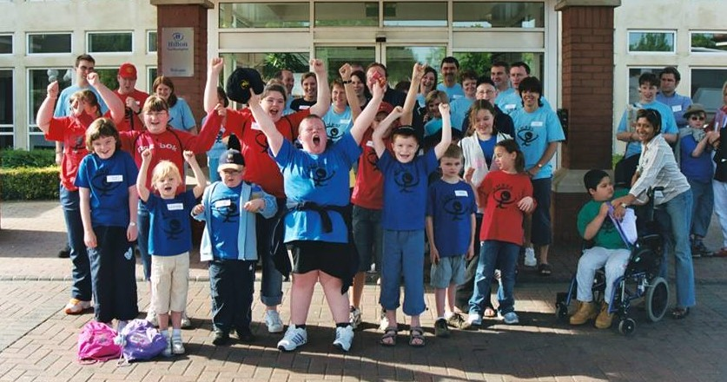


Contents
Administration Details 3
Bardet-Biedl Syndrome 4
Vision, Mission, Values. 4
Structure, Governance and Management 4
Additional Governance 6
Objectives and Activities 9
Report from the Chair of BBS UK 10
Achievements and Performance 11
Fundraising Review 14
Treasurer’s Report 16
Declaration 17
Accounts for year ended 31st March 2022………………………………………………………………..18
Independent Examiner’s Report……………………………………………………………………………21

Administration Details

Main Address: 43 Balton Way, Harwich, Essex, C012 4UP
Tel: 07591 206680
Web: www.bbsuk.org.uk
Email: admin@bbsuk.org.uk

Registered Charity in England and Wales: 1181244

Bankers: Barclays Bank PLC

Independent Accounts Examiner: Amicus Accountancy

President: Professor Philip Beales BSc LMSSA MD FRCP

Board of Trustees:

Chair: | Laura Dowswell
Vice-Chair: | Vacant
Secretary: | Dianne Hand
Treasurer: | Abbie Geeson
Trustee: | Judith Aylott
Trustee: | Rachael Foley
Trustee: | Stefan Crocker
Trustee: | Virginia Cashin (Retired 05/03/21)
Trustee: | Emma Oates (Retired 13/07/21)
Trustee: | Liam Wilkie (Elected: 13/07/21)
Trustee: | Dr Shehla Mohammed (Elected: 13/07/21)
Trustee: | Azrat Mirza (Co-opted: 23/09/21)

Bardet-Biedl Syndrome

Bardet-Biedl Syndrome is a rare, recessively inherited disorder which affects approximately 1 in 100,000 babies born. Features of the Syndrome include Rod-Cone Dystrophy, an eye disorder, characterised by tunnel vision and night blindness, which often leads to blindness; obesity; renal abnormalities; developmental delay; speech and language difficulties; extra fingers and/or toes and learning difficulties.

Not all of the features are always present in those diagnosed as having BBS and each one can vary in severity and appearance. The variability in presentation and severity of the Syndrome together with the rarity of the condition (there are approximately 600 diagnosed individuals known to us in the UK) can mean a delayed diagnosis and lack of adequate local health care.

Vision, Mission, Values

Vision: Our unique experience, knowledge and understanding of Bardet-Biedl syndrome, will ensure that everyone who accesses our services is supported, connected and informed about BBS and empowered to achieve the best possible outcome.

Mission: We are committed to promoting positive health and wellbeing within the BBS community; to improving knowledge and understanding amongst those affected, the medical and educational professionals and the wider public; and to supporting research and raising awareness of Bardet-Biedl syndrome.

Values:
- Committed and Passionate
- Inclusive and Community Minded
- Experienced and Understanding
- Positive and Forward Looking
- Collaborative

Structure, Governance and Management

Bardet-Biedl Syndrome UK (BBS UK), charity number 1181244 is a Charitable Incorporated Organisation (CIO) and was registered with the Charity Commission on the 18/12/2018. BBS UK is the only registered charity supporting people with Bardet-Biedl syndrome, their families and carers in the UK. The governing document of the Charity is a constitution. The CIO formally represents the incorporation of the unincorporated charity, Bardet-Biedl Syndrome UK (1027384), formerly known as Laurence-Moon-Bardet-Biedl Society and LMBBS which was established in 1993. The CIO is the successor body to the original Charity which was entered into the register of mergers on the 23/12/2020. The Board of Trustees is responsible for the governance of the Charity. The Charity now supports around 600 individuals living with BBS, their families and carers, and also the professionals supporting them across health, education and social care. Full membership of the Charity is open to any adult who has Bardet-Biedl syndrome and his/her family and any family with one or more affected children, including their grandparents and carers.
BBS UK Clinics Ltd is a Private Company Limited by Shares and is a wholly owned subsidiary of BBS UK.
Prior to BBS UK becoming a CIO, it was unable to trade according to the terms of its constitution. BBS UK Clinics Ltd was set up in 2010 following professional advice, and since then, the contract with NHS England to facilitate the specialist multi-disciplinary clinics has been managed through this subsidiary.
Since the Charity has become Incorporated, the Board of Trustees have reviewed whether it is necessary to continue trading via the Company, or whether it would be beneficial for the Charity to undertake its own trading, weighing up the risks, implications, and benefits of such a change.
On the 23rd September 2021, a resolution was put to the Board which was unanimously approved by the Trustees. From the 1st April 2022, the Company will cease trading and become dormant and the NHS England contract will transfer to the Charity. BBS UK will be receiving the remaining assets of the Company over the next 12 months and all employees of the Company will transfer to the Charity under TUPE (transfer of undertakings, protection of employment).

Trustees
Trustees are elected during the Annual General Meeting (AGM) of the Charity. Trustees serve three-year terms and a trustee who has served for two consecutive terms of three years each may not be re-appointed for a third consecutive term unless approved by members, but may be reappointed after an interval of at least three years. The members or the Trustees may at any time decide to appoint a new trustee in place of a trustee who has retired, been removed or as an additional trustee.

New trustees are given an opportunity to observe a board meeting, meet with the Chair of the Board of Trustees and Service Manager. They are supported with an induction process and are provided with the following:
- Trustee Information Booklet
- Constitution
- Strategic Plan
- Core Policies and Procedures
- Recent minutes of meetings and accounts
- Core safeguarding and information security training

The Honorary Officers of the Charity hold office for one year but are eligible for re-election annually. All trustees give their time freely and receive no remuneration or other benefits, however, reasonable incurred expenses are reimbursed as appropriate.
The Board seeks to be representative of the people with whom the Charity works and individual trustees have sufficient knowledge, both of trusteeship in general and of the Charity's activities, to enable them to carry out their role and to represent the Charity. Trustees are expected to undertake training to ensure they remain up to date with information and procedures. Courses attended have focused on developing governance skills, and include safeguarding, GDPR, recruitment and equality, diversity and inclusion training. The Charity Trustees will make available to each new trustee: a copy of the constitution and any amendments made to it; and a copy of the CIO’s latest Trustees’ Annual Report and Statement of Accounts.

BBS Clinics NHS Contract
Bardet-Biedl Syndrome UK has a contract with NHS England to facilitate the specialist multi-disciplinary clinics, which take place in Great Ormond Street Hospital and St Thomas’ Hospital, London and Birmingham Children’s Hospital and Queen Elizabeth Hospital, Birmingham. The requirements of the contract with the National Specialised Commissioning Team include:
- To maximise access to NHS provided services for patients with Bardet-Biedl Syndrome (BBS).
- To provide emotional and practical support and advocacy services for patients affected by BBS and their families.
- To provide information relating to services provided for patients with BBS, including relevant health promotion and lifestyle information, to maximise the health and life chances of people living with BBS.

To achieve the above, information and support is provided to the patients and their families/carers before, during and after clinics. Accommodation is organised for patients when needed and assistance is given with travel arrangements. This service provision ensures patients and their families are well informed about the syndrome and feel well supported to attend their clinic appointment. BBS UK has a presence at each clinic, offering emotional and practical support to patients and their families and ensuring they are aware of all relevant benefits and social support services. Post clinic, ongoing support and liaison services are available.

Additional Governance

Policies and Procedures
BBS UK has the following policies in place:

- Business Continuity | - Handling of DBS Certificate Information
- Bring your own device | - Health and Safety
- Child Protection | - Lone Worker
- Code of Conduct | - Management Structure
- Complaints | - Pay Review
- Conflict of Interest | - Reserves
- Dignity at Work | - Safeguarding Vulnerable Adults
- Disciplinary | - Social Media
- Driving Whilst on Business | - Trustee Recruitment
- Equal Opportunities | - Volunteer
- Finance | - Whistleblowing
- Grievance

BBS UK has the following Information Security policies in place:

- Anonymisation & Pseudonymisation Information
- Collection and Recording of Service User Data
- Confidentiality / Code of Conduct
- Data Impact Assessment Procedure
- Data Protection
- Data Retention and Disposal
- Email Use
- Handling of DBS Certificate Information
- Home Working - Handling
- Information Governance
- Information Sharing
- Information Security Reporting and Auditing
- Privacy Notice
- Subject Access Request.

BBS UK has the following handbooks in place:

- Health & Safety Handbook
- Information Governance Handbook
- Staff Handbook

Additional quality assurances
BBS UK has Cyber Essentials Certification which is an official UK wide government-backed scheme that provides protection against the most common cyber threats and demonstrates our commitment to cyber security.

BBS UK has completed and published NHS Digital’s Data Security and Protection Toolkit, an online self-assessment tool that allows organisations to measure their performance against the National Data Guardian’s 10 data security standards and to provide assurance they are practising good data security and personal information handling.

BBS UK has achieved PIF TICK accreditation following a thorough application and assessment process. The PIF TICK is a mark of quality and demonstrates that our health information has been through a professional and robust production process.

Disclosure and Barring Service checks (DBS) are carried out prior to commencement of employment, trusteeship and volunteering duties. DBS checks are carried out regularly in line with statutory requirements. Child Protection Training and Safeguarding Vulnerable Adults Training is undertaken by those working or volunteering with children, young people and/or vulnerable adults, their line managers and their governing board.

How we look after and safeguard information
BBS UK aims to provide members and patients with the highest quality support and information and to do this we need to collect, process and store information.

BBS UK processes and stores information in accordance with:
- The Data Protection Act 2018 incorporating UK GDPR.
- The Human Rights Act 1998
- The Common Law Duty of Confidentiality
- The Caldicott Principles
- NHS Code of Practice on Confidentiality

BBS UK maintains compliance via:
- Established and routinely maintained policies and procedures for the effective and secure management of information assets and resources
- Annual audits of its information and IT security arrangements
- Effective confidentiality and security practices promoted to staff through policies, procedures and training
- Incident reporting procedures and monitoring/investigation of all reported instances of actual or potential breaches of confidentiality and security
- BBS UK is registered with the Information Commissioner’s Office (ICO) which ensures BBS UK comply with the Data Protection Act 2018 and GDPR regulations are processing personal information in a fair and transparent manner.

For this reporting period, BBS UK reported no breaches in security and no ‘near misses’.

Objectives and Activities

BBS UK strives to bring together through our projects and services, support to our members. BBS UK Trustees have regard to the Charity Commission's public benefit guidance when exercising any powers or duties to which the guidance is relevant. The Trustees always ensure that the projects and services we undertake are in line with our charitable aims and objectives.

The main objectives of Bardet-Biedl Syndrome UK are:

- To preserve and protect the health and promote the welfare of persons affected by Bardet-Biedl syndrome and their families
- To advance the education of the medical and educational professions and the general public on the subject of Bardet-Biedl syndrome and its implications for the family, and to promote research for the public benefit in all aspects of that subject and to publish the useful results.

The main activities the charity undertakes in pursuance of its objectives for the public benefit are:

- BBS Clinic Support Team providing support, facilitation and advocacy services to NHS multi-disciplinary clinics
- Advice Service supporting members with accessing local support across the areas of health, education, social care and benefits.
- Information booklets available in multiple formats, including:
  - Medical Information Booklet
  - Introducing Bardet-Biedl Syndrome
  - Booklet for Schools and Colleges
  - My Life, My Future (Transition Handbook)
  - Who We Are and How We Can Help
- Annual family conference weekend bringing beneficiaries together with interested professionals and experts, to provide access to the latest research and to participate in tailored workshops.
- BBS UK website: www.bbsuk.org.uk
- Regular newsletters and an annual conference report
- Social Media (including Facebook, Twitter, YouTube) in order to facilitate the development of an online community.
- Young People’s Group (YPG) and Adult Focus Group (AFG).

Report from the Chair of BBS UK
Laura Dowswell, Chair

The last couple of years have presented many challenges for our charity and for our community, and the BBS UK Board of Trustees and staff team have worked incredibly hard to meet those challenges. Not only to maintain the delivery of the Charity’s vital services, and to ensure that the Charity continues to be sustainable, but to develop our services to meet the increased needs of our community during this difficult time, and to ensure we can meet those needs into the future, all within the very tough economic environment we have faced.

We have been very fortunate to be able to extend the support available with the creation of two new Assistant Patient Liaison roles and an Admin, Engagement & Events Co-ordinator role; we are delighted to welcome Laura, Shirin and Léonie to the team.
In response to the needs of our members, we developed the BBS UK Advice Service to provide high quality support with accessing local services across housing, social care, benefits and education; the work that is being undertaken and the outcomes that are being achieved have quickly shown that this is an essential core service and a primary funding focus for BBS UK.

The Clinics Team have continued to provide excellent support to the service and to patients attending the face to face and telemedicine clinics and, even during the pandemic, we have been able to access vital clinical services.
There have been a number of team projects undertaken during the last year, including the IT Equipment Fund, our partnership with Slimming World and our newly formed Regional Group in Ireland.
Last year we were unable to come together due to the pandemic and although this brought disappointment, it also brought positivity and excitement as we embraced the technology and developed a two-day online conference via the Zoom platform. The social aspect that is so enjoyed at our events was undoubtedly missing, but everyone relished the opportunity to come together. Furthermore, having the event online enabled us to reach a wider audience, including overseas delegates, local care teams, extended family members and those who would find attending the event too difficult. Conference 2022 will be held in person but we will also live-stream the event to ensure we maintain this momentum.

I hope that like my family and I, you are very much looking forward to connecting with others at this year’s conference. It will be a wonderful opportunity for us to come together as a community and meet friends, both old and new.

On behalf of the Board and also personally, I would like to offer sincere thanks, firstly to the staff team who have faced unprecedented challenges due to the pandemic but have shown resilience and commitment throughout, and also to my fellow trustees who freely and willingly give up their free time. Also to all those who have continued to fundraise throughout and to those who have regularly contributed through the Friends scheme.

Team BBS UK is made up of trustees, staff, volunteers, members, supportive professionals, fundraisers, donors, campaigners, supporting charities and organisations, and that is how we have managed to come through the pandemic and how we will continue to grow and provide the support and information services that our community needs: by continuing to work together and by developing new ways of working, in order to improve the lives of all those living with Bardet-Biedl syndrome.

Achievements and Performance
Tonia Hymers, Service Manager

Introduction
Following an incredibly difficult year, 2021 proved to be equally challenging with further restrictions and ‘lock-downs’ increasing the anxiety and isolation of the BBS community. It became apparent that many had fragile support systems in place which did not stand up to the impact of Covid and, in this respect, the pandemic has exposed/highlighted areas of risk and safeguarding that have previously gone unnoticed. In addition to responding to the immediate needs of our community, this reporting year has been about listening to our members and understanding what will be needed going forward. We have been reviewing the work that has been undertaken to date, determining our core services and considering new and innovative ways of delivering exceptional support. During a year when many charities have cut services, we are incredibly proud to report a year of growth and development, which is in no small part thanks to having such a dedicated and committed team of trustees, staff and volunteers.

Staff Team
The impact of Covid at the beginning of 2021 was increasingly felt among the staff team, as many of them juggled their work responsibilities with home-schooling their children and caring responsibilities, as well as the many other effects of Covid. We supported our team throughout this difficult period by making use of flexible working, furlough and flexi-furlough where needed. Our approach has been rewarded with exceptional commitment and dedication from the team to the organisation and its service users. Midway through the year, we were fortunate to be able to grow our support team with the addition of Laura and Shirin. Later in the year, Léonie joined the team, working on admin, engagement and events. They have all very quickly become invaluable team members, committed to our membership and charity and we are excited to see what we can achieve together into the future.

BBS UK Advice Service
At the beginning of the reporting year we realised that our community, already struggling to access local support services, was going to need additional support because services were under increasing funding pressure while facing rising demands. In response, we developed the BBS UK Advice Service to provide high quality support with accessing local services across housing, social care, benefits and education and this has quickly established itself as an essential core service and a primary funding need for BBS UK. Our Advice Service and Clinics Support Team work closely together, to ensure the best possible provision for those who need it.

BBS Specialised Clinics
The pandemic has inevitably impacted upon the NHS-funded BBS clinics service, with follow-up appointment times stretching to two years and beyond. However, the teams have adopted a hybrid approach, offering a mix of face to face and telemedicine appointments at each centre, to reduce the waiting times and improve access and attendance. Those who are still anxious about returning to a face-to-face clinic, or who find travelling to clinic too difficult, are well supported via the telemedicine service; it has also proven useful for those who are isolating or who have tested positive for Covid but are otherwise well. The BBS UK team continue to ensure high levels of attendance and provide excellent support to patients to be certain that they get the most out of each clinic appointment.

The impact of the past two years is going to be felt for some time, with local healthcare services struggling to catch up, leaving many of our community finding it difficult to access the local support they need. The BBS clinics teams have been supportive throughout, providing a much-needed point of contact and care co-ordination provision, where appropriate. Our heartfelt thanks go to the BBS teams at all four centres, for their continued dedication and commitment to our community.

Events
It was clear very early on in the year that we would be unable to resume our face to face events for the foreseeable future; however we organised a very successful two-day online conference. Day one was aimed at professionals involved in the care, support and education of those with BBS, and day two was aimed at those living with the syndrome, their families and carers. We were well supported by a wide range of professionals and experts in BBS and the programme across the two days was packed with relevant, interesting and exciting presentations that provided a sense of hope and community for us all. Feedback was overwhelmingly positive and, although we missed being able to spend time together in person, everyone enjoyed the interaction and feeling of community that was generated. Having the event online increased accessibility and enabled us to deliver to a wider audience and future events will be live-streamed. Planning for Conference 2022 is underway and will return to the Hilton, Northampton.

Publications
We reviewed and updated our ‘My Life, My Future’ transition handbook for young people which informs the basis of our transition work, to be developed over the coming year. We also produced a Newsletter and Conference Report, both of which are sent out in accessible formats including audio CD and email.

Additional Projects:

The Maypole Project: Having secured an unrestricted grant at the beginning of the year, we embarked on a collaboration with The Maypole Project, developing a pilot scheme to provide counselling and support to those who are isolated and experiencing social anxiety. The programme offers six one-to-one counselling sessions, followed by group therapeutic sessions to enable participants to develop their confidence and social/communication skills, within a supportive setting. Going forward, BBS UK will work with the participants to maximise the impact of this project, ensuring that they have the local support needed to access their local communities and to make the most of their developing skills and confidence.

IT Equipment Scheme: This scheme is for those who need a computing device to support them with accessing social and educational opportunities and medical care. Our team will first assist with accessing external funding and, where this is exhausted, will go on to fund a device which may be a desk-top, lap-top or tablet.

Slimming World on Referral: BBS UK are working in collaboration with ‘Slimming World on Referral’ to offer 12 weeks of free membership to those diagnosed with BBS who are wishing to lose weight. Results are mixed; however many participants have lost considerable amounts of weight and are reporting improved wellbeing.

Regional Groups: BBS UK is committed to developing Regional Groups to improve local support and communication. This has commenced with the development of BBS UK: Ireland. This important work will continue during the coming year and will expand to include BBS UK: Scotland.

Collaborative Working / Raising Awareness
BBS UK are connected to many other charities and umbrella organisations, both formally and informally. Our organisation benefits from attending conferences, seminars, networking and training events, all of which enable us to raise awareness and identify opportunities for learning and collaboration. Many of these events remained online during the reporting year and we continued to make good use of them.

During the year, we have presented to the UK Cilia Network and to Genomics Masters students within their learning module. We are also represented on the Ciliopathy Alliance and BBS International boards. We benefit considerably from working with these organisations and, in particular, we have enjoyed working with our counterparts across the world in the development of BBS International; 2021 saw the very first BBS Global Day.

Research
We have supported research projects, from providing letters of support to disseminating research information and questionnaires. In support of our growing engagement in research, we attended a NICE Induction, which provided an overview of patient and public involvement in medicine appraisals at NICE. When technologies are put to NICE, all stakeholders are asked to provide a submission of evidence to enable a holistic appraisal to take place. This is an area in which BBS UK, and our membership, can work together to ensure that the wider BBS voice and experience is heard and understood.

Three Year Strategy
We have reviewed our services and organisational development and finalised our three-year strategy, formalising our vision, mission and values. A key aspect informing this work is the BBS UK Membership Audit, which asked about the impact of the Syndrome and sought to understand what BBS UK can do to better support our community. The aims and objectives for the coming three years are therefore to:

- Improve communication with our service users
- Develop our support services and reduce isolation
- Empower our membership to achieve
- Strengthen governance and raise our profile
- Support research and understanding of BBS

Feedback received:
- “I am very grateful for the support I have from the liaison officer. I can call her any time and talk to her.”

- “Without the support of BBS UK, life would be more difficult.”

- “BBS UK is my second family. Thank you so, so much for all your support.”

- “From the moment we contacted the society 19 years ago, the service and support we have received has been fantastic and a lifesaver.”

- “When my son had a diagnosis of BBS it was so reassuring to have an organisation to turn to for further information, support and to meet other families who had been/were going through the same as us.”

- “BBS UK has had a positive impact on how we adjusted to my son’s diagnosis.”

Fundraising Review
Christine Saxon, Fundraising Officer

I would like to thank all of our supporters for their incredible resilience, imagination and hard work in fundraising for BBS UK over the past 15 months. Our fundraising effort has expanded so much in the past seven years, which has allowed our services and support to develop. The figures this year must be read with a cautionary note as they cover 15 months of income, due to the charity year end being extended from December to March. In addition, this year’s figures are against a diminished annual income last year following the Covid-19 pandemic and the allied restrictions on socialising. Total income this year is £154,564.
This year we have increased our Friends of BBS UK numbers. Furthermore, several of our existing Friends have increased their donations, to bring in just under £10,000. This is regular known income, which helps BBS UK to plan for service delivery, and is vital to our overall income.
For the first time, we have attracted gifts from a variety of foundations, trusts and grants; these donations, which are a considerable addition to our other activities, have amounted to over £45,000. We are appreciative of their impact on the charitable sector throughout the pandemic, and also for the future.
Several larger fundraising events this year have collectively raised over £13,000, including a BBS UK BBQ in Northern Ireland and an equestrian event in the West Midlands. We are pleased that these larger events are now being organised and we encourage all members to share their ideas because, with help available, the more elaborate events may well be possible.
Runs, walks, garden parties, quiz nights and challenge events have all had their place in fundraising in the community for the past 15 months; two newer ideas of having a face painting stall and a nail day at a beauty salon, proved popular. Thank you to you all for your ideas, time, efforts, and commitment to raising over £38,632.
Just Giving, Paypal and Charitable Aid Foundation continue to provide a relatively easy way of allowing supporters to sponsor your ventures, as well as adding Gift Aid to the donations. Sadly, Virgin Giving, another payment platform you have used mainly for Marathon fundraising, has ceased this year, but we thank them for the way in which they have helped us to raise income in the past.
Gift Aid remains a critical part of our income, as all eligible gifts with Gift Aid bring in an extra 25p for every £1 given. On a £10 gift that is £2.50, on a £100 gift that is £25 and it costs nothing to the individual. This year, compared with the last financial year, our Gift Aid has dropped from £4,730 in a 12 month period to £2,096 in a 15 month period. Wherever possible, please continue to tick the box that says you would like us to claim Gift Aid on your gift…a tick in the box if you are eligible, what could be easier?
On a very positive note, this year we have had more donations coming in from companies. This includes employers who will match-fund the money you raise for BBS UK, employers who have a nominated Charity of the Year, and employers who will make donations through matching their employees’ wages, via Payroll Giving. Keep up the excellent work by asking if your company, workplace or corporate organisation will do this; it will encourage more income, as well as spreading the word further about BBS UK.
We have recently developed a Fundraising Sub-Committee, bringing together staff and Trustees to share ideas, look at income and develop best practice within the fundraising function. I am grateful to them for their hard work and enthusiasm.
This has been a great year, where families, friends and new supporters have all combined to move BBS UK out of the pandemic into an exciting future. I have been moved by the support we have received during this particularly challenging time and look forward to writing the next report in 2023.

Treasurer’s Report
Abbie Geeson, Treasurer

BBS UK extended its financial year to incorporate 1st January 2021 – 31st March 22. Therefore, the financial accounts reflect a 15-month period.

As previously described, BBS UK Clinics Ltd, a wholly owned subsidiary of BBS UK, will become dormant and all assets will be transferred to the charity. In March 2022, BBS UK received a dividend payment from the Company from its retained capital and reserves as of the 31st March 2021 and this is reflected within the income report below and the financial accounts.

Income during this financial year was £154,564 (2020 £53,704). This includes:
- £80,468 unrestricted grants, donations and member fundraising events.
- £3,684 other income from shared costs and the HMRC Job Retention Scheme.
- £20,000 restricted grants.
- £50,412 dividend received from BBS UK Clinics Ltd.

Expenditure during this financial year was £93,539 (2020 £55,174). This includes:
- £79,874 unrestricted expenditure
- £13,664 restricted expenditure from funds previously carried forward and newly received grant spend.

The unrestricted fund had a surplus of £54,690. As of the 31st March 2022, unrestricted funds were £159,328 (2020 £104,638)

During the reporting period:
- There were no guarantees given by the CIO. (This is where a potential liability under a guarantee is outstanding at the date of the statement).
- There were no debts outstanding by the CIO. (This is money owed which would be secured by an express charge on any assets of the CIO).

Reserves Policy
Trustees regularly review the budget and the level of reserves, which are monitored on a monthly basis and reported at the quarterly board of trustee meetings.
Trustees have agreed unrestricted reserves should be sufficient to cover six months expenditure, to manage income shortfalls and to meet any unforeseen expenditure which may occur.
The total Charity funds as of the 31st March 2022 were £172,405. These are represented by restricted funds of £13,078 and designated funds of £38,125. This leaves general funds of £121,202 which is free reserves. The free reserves represent six months of expenditure.

The purpose of the designated funds are as follows:
- The Chris Humphreys Memorial Fund £955 – This subsidy fund was set up in 2020 to support newly diagnosed individuals and their families to access our events.
- The Annual Family Weekend and Conference £24,045 is committed future expenditure. The weekend brings together over 200 diagnosed individuals and their families.
- The IT Equipment Fund £7,170 - This fund was set up in 2021 in response to an increasing need for people with BBS to access services through means of digital technology based upon an assessment of need.
- The Advice Service £5,955 – To support the development and growth of this new integral BBS service.

The trustees have reviewed the circumstances of the Charity and consider that adequate resources continue to be available to fund its activities for the foreseeable future. The trustees are of the view that the charity is a going concern.
Management of risk
BBS UK relies on income from donations and fundraising events undertaken by its membership and through the Friends of BBS UK donation scheme.
The main financial risks to the charity are:
- The NHS England contract
- Failing to secure sufficient funds
- Loss of income from reduced donations
- The loss of key personnel
- The Covid-19 pandemic

Declaration

The Trustees approve this annual report and accounts.

Signed on behalf of the Board of Trustees:

L Dowswell

Laura Dowswell
Position: Chair
Date: 10th June 2022

Accounts for year ended 31st March 2022
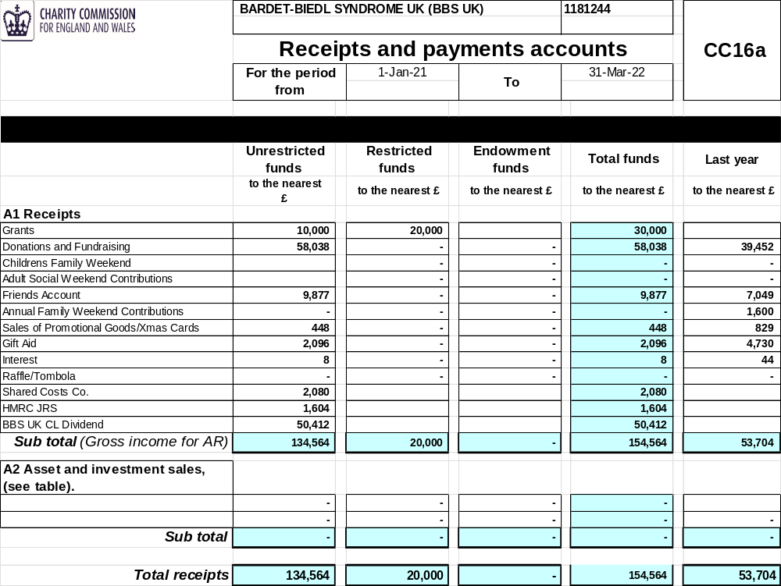
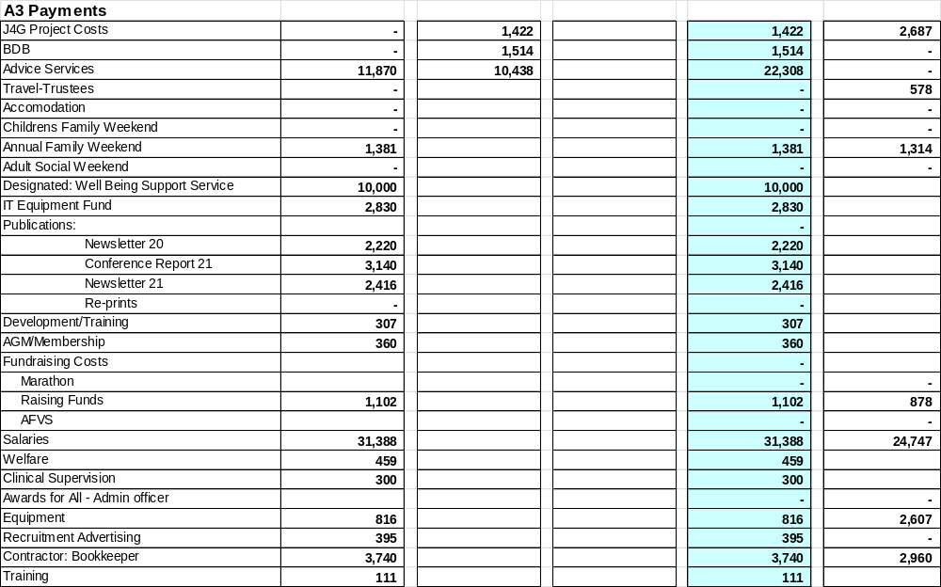

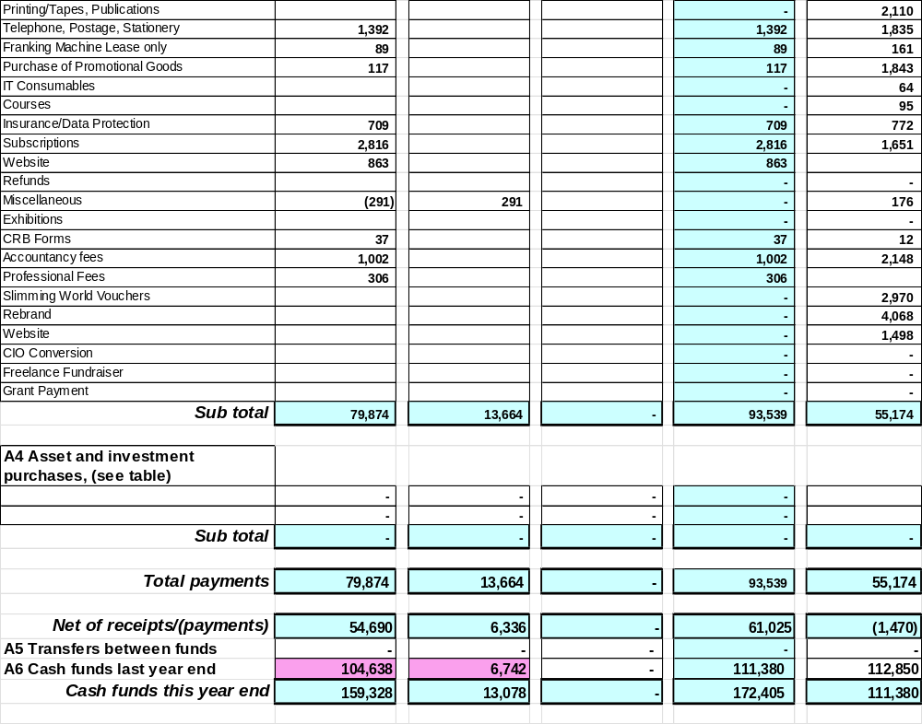
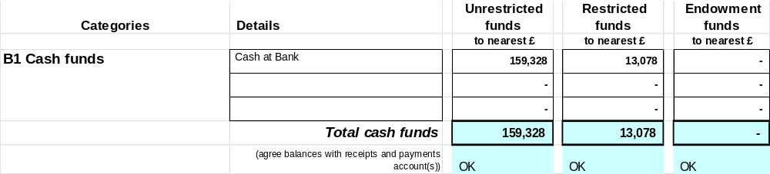
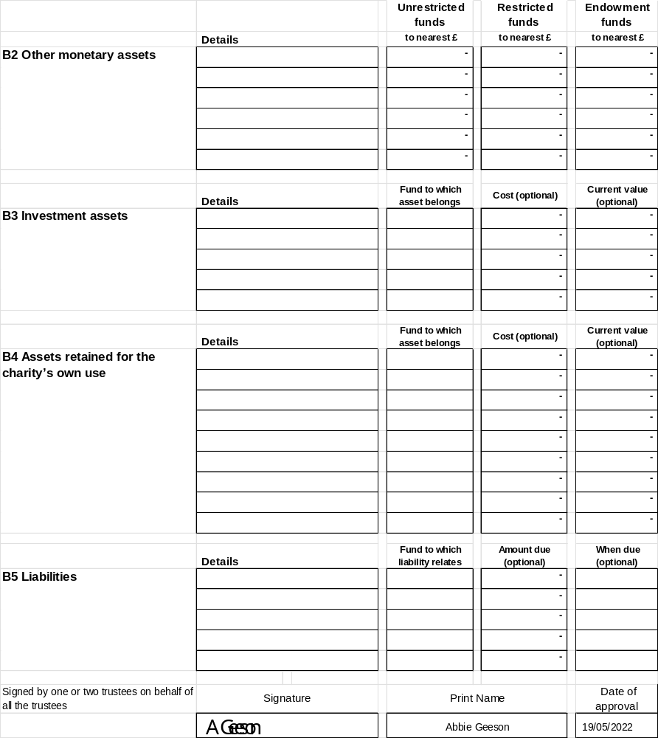

Independent Examiners Report





