BBS UK Young Person Activity Weekend 2024

Date: 27th September – 29th September
Location: Birmingham, UK
Price per person: £100.00

Who is this for?
- Young person with BBS in years 7-11 of secondary school accompanied by one parent or carer
- Members of BBS UK

What’s included?
The cost of £100.00 per person will include:
- Two-night stay at the Travel Lodge, including hotel breakfasts
- Friday evening meal, Saturday lunch, and Saturday evening meal
- 12-hole indoor golf for the young person
- Coach to and from The Bear Grylls Experience and 4 activities for the young person (archery, climbing, high ropes or axe-throwing, and an assault course)
- Two games of bowling for the young person
- BBS UK staff assisting all weekend
- A chance to connect with peers who also have BBS

*Please note that adults accompanying the young person will not be taking part in the activities as the weekend aims to encourage the young people to interact with each other and make friends.*
We don’t want money to be a barrier for families who want to attend. If you are struggling financially and receive means-tested benefits, please contact us and we may be able to provide assistance to you.

How to get there
By train
Option 1: Arrive at Birmingham New Street train station, and then get a taxi to the Travel Lodge.
Option 2: Arrive at Birmingham New Street train station, then get a connecting train to Five Ways station (one stop), then walk 12 minutes to the Travel Lodge.
By car
Parking is available at the nearby APCOA car park. Address: 220 Ladywood Middleway, B16 8LP
24-hour parking is charged at £12.00.

Weekend programme
Friday 27th September
When | What | Where
From 3:00pm | Hotel check-in | Travel Lodge Birmingham Central Broadway Plaza
6:30pm – 8:45pm | Crazy golf and evening meal | Mr.Mulligan
Saturday 28th September
When | What | Where
From 8am | Breakfast | Travel Lodge Birmingham Central Broadway Plaza
9:30am | Coach pick-up (around 30 mins travel time)
10:30am – 3:00pm | Activities and lunch | The Bear Grylls Adventure
3:30pm | Coach pick-up (around 30 mins travel time)
4:00pm – 6:00pm | Free time | Travel Lodge Birmingham Central Broadway Plaza
6:00pm – 8:00pm | Bowling and meal | Hollywood Bowl
Sunday 29th September
When | What | Where
From 8am | Breakfast | Travel Lodge Birmingham Central Broadway Plaza
10am | Goodbyes
*Please note that timings for the weekend are estimated and may change*

FAQ
Will BBS UK pay for my travel?
Attendees will need to pay for their own travel. However, if you’re struggling financially to pay for travel and are in receipt of means-tested benefits, we may be able to provide some monetary assistance to you. Please contact us to discuss.
Who will support my child during The Bear Grylls Adventure activities?
The Bear Grylls Adventure have trained staff to assist the young people taking part in the activities. They are experienced in supporting people of various abilities.
How many people will be attending?
There will be 45 people in total including:
- 5 BBS UK team members
- 20 young people
- 20 parents/carers
Is my booking confirmed once I’ve completed the booking form?
No. Your booking is confirmed when you receive a booking confirmation email from BBS UK admin@bbsuk.org.uk
How do I pay for the activity weekend?
After your booking has been confirmed, we will contact you to arrange payment. We will request the payment through BACS bank transfer. Payment will be due before 28th June 2024.

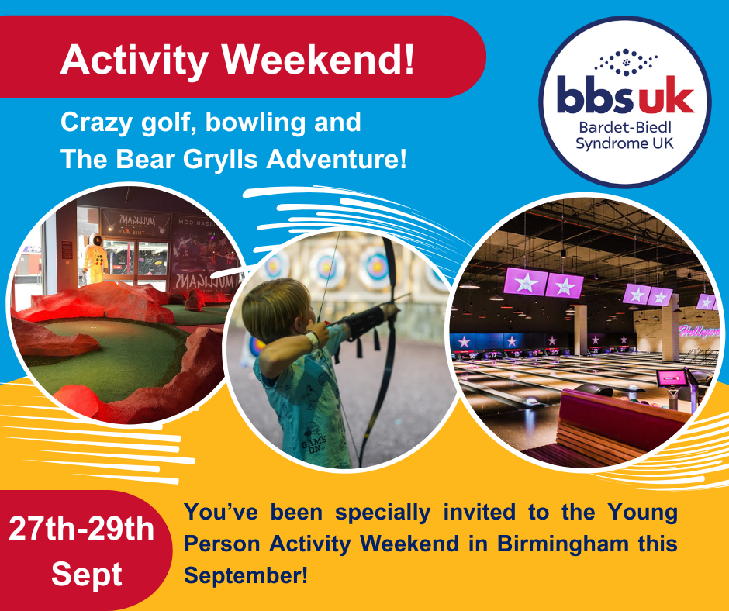

We hope you can join us!
Team BBS UK

